INTRODUCTION TO THE ABDOMINAL CAVITY AND VISCERA

Study Objectives:

1. Understand how organs, vessels, and autonomic innervation relate to the embryonic foregut, midgut, and hindgut organization.

2. Understand the named “ligaments” of the dorsal and central mesenteries of the gut, and how these differ from the “ligamentous” adhesions and fibrous cords.

3. Understand the three major events which complicate the simple embryonic organization of the abdominal contents:
a. the longitudinal rotation of the foregut 90 degrees and the growth of the dorsal part of the stomach;
b. rotation of the midgut 270 degrees around the superior mesenteric artery and subsequent tremendous growth of the small intestine; and
c. the formation of the lesser peritoneal sac by outgrowth of the dorsal mesogastrium.

4. Understand the difference between intraperitoneal organs and primarily and secondarily retroperitoneal organs.

5. Understand the general function of abdominal viscera.

6. Understand the function of the portal system and communication with the caval system.

Knowing the above should lead you to an easier understanding of adult anatomy of the abdomen and provide you with an organizational framework for study.

What you will not get from this lecture, but you should learn from texts and laboratory:

1. Adult anatomy of the anterior abdominal wall: muscles, fascia, and their weaknesses (hernias).

2. A thorough knowledge of the adult anatomy of the abdominal viscera.

New Terms:

Organs:
stomach liver gall bladder
pancreas spleen duodenum
jejunum ileum cecum ascending colon transverse colon descending colon sigmoid colon
rectum kidneys ureters
urinary bladder urethra pronephros
mesonephros metanephros

Vessels:
celiac trunk common hepatic a. splenic a.
left gastroepiploic a. left gastric a. superior mesenteric a.
inferior mesenteric a. hepatic portal system splenic v.
superior mesenteric v. inferior mesenteric v. left gastric v.
portal caval anastomoses (4)

Ligaments:
falciform ligament hepatoduodenal ligament hepatogastric ligament
gastrolienal ligament lienophrenic ligament lienorenal ligament
ligamentum teres ovarian ligament round ligament of the uterus
gastrocolic ligament phrenicocolic ligament hepatocolic ligament
broad ligament of the uterus suspensory ligament of the ovary
mesovarium mesosalpinx

Other Terms:
foregut midgut hindgut
mesentery mesothelium serosa
peritoneum mesogastrium mesointestine
mesocolon greater peritoneal sac lesser omentum
greater omentum lesser peritoneal sac epiploic foramen
common bile duct main pancreatic duct peristalsis
intraperitoneal primarily retroperitoneal secondarily retroperitoneal
autonomic innervation sympathetic nerves parasympathetic nerves
splanchnic nerves collateral ganglia extrinsic autonomic plexuses
Vagus (CN X) nerve

The Gut Tube:

Section | Derivatives | Artery
 | Stomach (S)
 | Liver (L)
Foregut | Gall bladder (G) and  bile apparatus | Celiac  artery
 | Pancreas (P)
 | Duodenum (D)
Duodenum (D)

Jejunum (J)
 | Ileum (I)
Midgut | Cecum (C) | Superior  mesenteric  artery
 | Appendix (A)
 | Ascending colon (A)
 | Transverse colon (T)
Transverse colon (T)

Descending colon (D)
Hindgut | Sigmoid colon (S) | Inferior  mesenteric  artery
 | Rectum (R)

* The spleen develops in association with the foregut, but is not actually a derivative of the foregut.

The organization of the abdominal cavity can best be studied in the embryo, where the organs develop as outgrowths from the straight gut tube. The relationships are simple -- and remain simple in the adult. The appearance of the adult anatomy in the abdomen is complex due only to the tremendous growth, rotation, and packing of the organs in a limited amount of space.

The gut tube is formed as the spherical yolk sac is compressed by the transverse folding or bending of the embryo. The straight, endodermal gut tube can be divided caudal to the diaphragm into the abdominal foregut, midgut, and hindgut. Note that the derivatives of the foregut continue cranial to the diaphragm and include the esophagus and the pharynx.

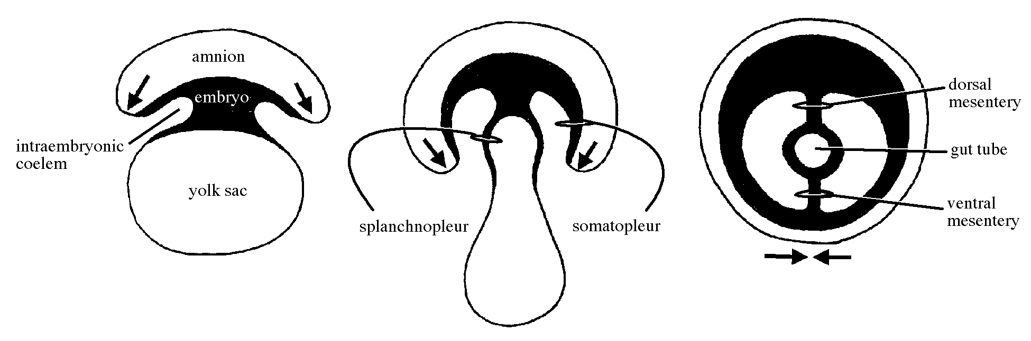

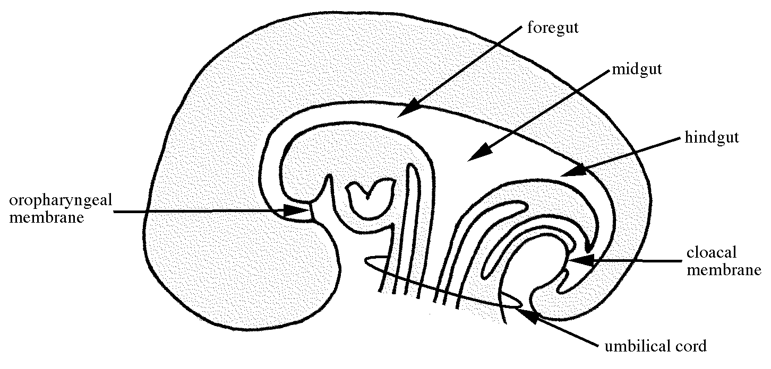

Mesenteries:

Mesenteries are opposing layers of visceral (as opposed to parietal) mesothelium, the simple squamous epithelium lining the body cavities (also called serosa). Mesenteries are continuous with the visceral mesothelium covering organs and parietal mesothelium lining the body cavities. The mesothelium in the pleural cavities is called pleura, pericardium around the heart, and peritoneum lining the abdominal cavity. Mesenteries function to support the viscera and as a route by which vessels, nerves, and lymphatics can reach the organs. They are named according to the organs they support, e.g., mesogastrium, mesointestine, mesocolon, mesocardium, etc.

Initially, there are dorsal and ventral mesenteries the entire length of the GI tract, but the ventral mesentery of the midgut and hindgut break down so that the left and right halves of the abdominal cavity become continuous with each other to form the greater peritoneal sac (of parietal peritoneum). The ventral mesogastrium in the foregut and the entire dorsal mesogastrium remain intact. Mesenteries connecting different organs in the abdomen are called ligaments.

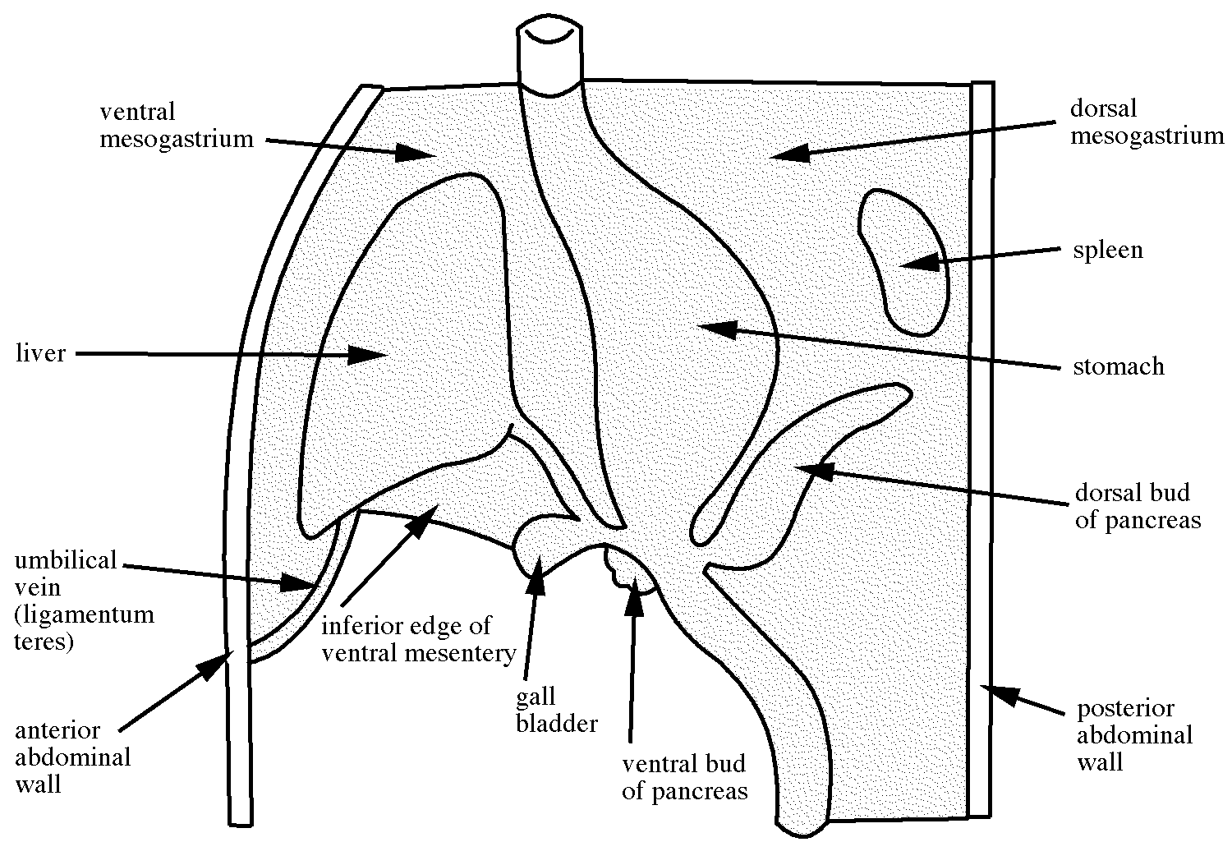

Mesenteries and Structures That May Be Difficult to Understand:

Dorsal mesentery derivatives:

greater omentum: a sac formed in the dorsal mesogastrium that evaginates to the left, collapses, and drapes down over the intestines; functions to seal off local infected areas of the parietal peritoneum

lesser peritoneal sac: the potential cavity inside the greater omentum

epiploic foramen: the entrance to the lesser peritoneal sac

gastrolienal ligament: a remnant of the dorsal mesogastrium between the greater curvature of the stomach and the spleen

lienophrenic ligament: (lien=spleen) remnant of the dorsal mesogastrium between spleen and diaphragm

lienorenal ligament: a remnant of the dorsal mesogastrium between the spleen and the posterior abdominal wall (near the left kidney)

Ventral mesentery derivatives:

lesser omentum: part of the remaining ventral mesentery of the abdominal foregut (ventral mesogastrium: meso = mesentery, gastrium = stomach) between the stomach and the liver. The lesser omentum consists of the hepaoduodenal and heptogastric “ligaments” (see next page for definitions).

falciform ligament: a remnant of the ventral mesogastrium, connecting the ventral liver to the anterior abdominal wall.

hepatoduodenal ligament: a remnant of the ventral mesogastrium between the liver and the duodenum

hepatogastric ligament: a remnant of the ventral mesogastrium between the liver and the lesser curvature of the stomach (the combination of hepatogastric and hepatoduodenal ligaments comprises the lesser omentum)

Other structures which are referred to as “ligaments” are not true mesenteries. These include
i) fibrous cords:

ligamentum teres: remnant of umbilical vein

ovarian ligament and round ligament of the uterus: both remnants of the gubernaculum which, in the male, guides descent of the testes

and ii) adhesions:

gastrocolic ligament: transverse mesocolon plus greater omentum

phrenicocolic ligament: suspensory ligament of the spleen; supports left colic flexure

hepatocolic ligament: supports right colic flexure

True mesenteries of the pelvic region include the broad ligament of the uterus and its subdivisions or extensions:

suspensory ligament of the ovary: most lateral part of broad ligament

mesovarium: posterior fold of broad ligament containing ovary and the fibrous ovarian ligament

mesosalpinx: superior free edge of broad ligament containing uterine tube

Peritoneal Classification:

Intraperitoneal organs are freely suspended by mesenteries: stomach, liver, gall bladder, spleen, jejunum, ileum, transverse colon, sigmoid colon, uterus, and ovaries.

Primarily retroperitoneal organs develop and remain outside the peritoneal cavity: kidneys, suprarenal glands, aorta, inferior vena cava, urinary bladder, prostate, vagina, and rectum.

Secondarily retroperitoneal organs develop in mesenteries, but get pushed against the body wall (parietal peritoneum) during growth so that only half of their surface or less is covered by peritoneum. These organs only appear to be retroperitoneal: pancreas, duodenum, ascending and descending colon.
Abdominal Foregut:

The abdominal foregut extends from the diaphragm to where the common bile duct in the free edge of the falciform ligament (connecting the ventral liver to anterior abdominal wall) joins the first part of the duodenum.

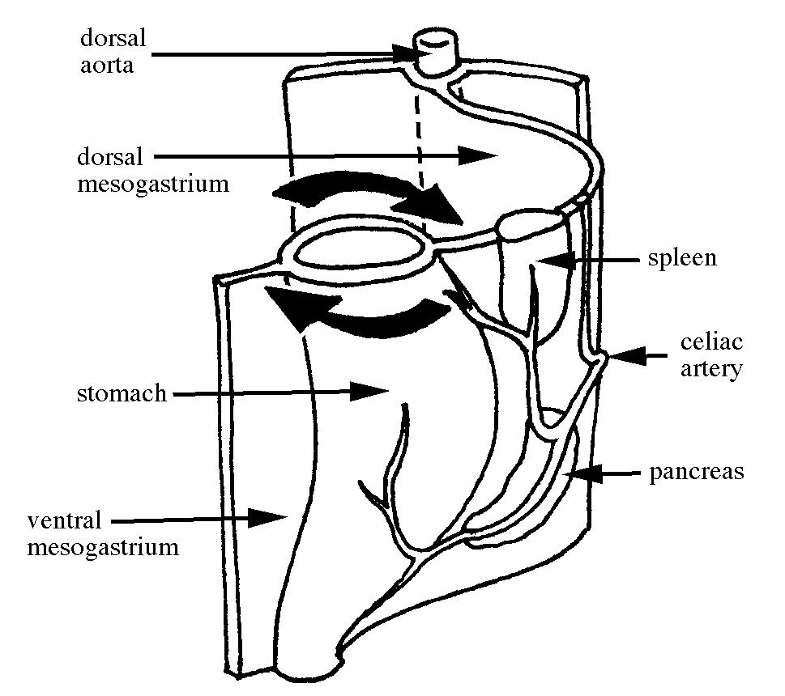

stomach: develops as a dorsal swelling of the foregut tube. Later in development, it rotates 90 degrees clockwise on a longitudinal axis so its dorsal surface (greater curvature) faces left.
Function: a blender and reservoir where digestive juices act on food
Identify: lesser curvature, greater curvature, pylorus, esophageal sphincter, pyloric sphincter

liver and gall bladder: form in the ventral mesogastrium as outgrowths of the foregut tube. The liver separates the mesogastrium into: i) lesser omentum which lies between the liver and the lesser curvature of the stomach; and ii) the falciform ligament which lies between the liver and the ventral abdominal wall.
Function: liver is storehouse for glycogen and secretor of bile; gall bladder is reservoir for bile
Identify: bare area, four lobes (right, left, caudate, and quadrate)

pancreas: an outgrowth of the foregut which ends up in the dorsal mesogastrium; its main pancreatic duct joins the bile duct as it enters the duodenum. The dorsal pancreatic bud evaginates from the foregut. The ventral bud comes off the liver bud stalk and migrates up into the dorsal mesentery. The pancreas lies in what will become the rear wall of the greater omentum. This rear wall adheres to the dorsal parietal peritoneum later, immobilizing the pancreas.
Function: produces an external secretion (pancreatic juice) that enters the duodenum via the pancreatic duct and internal secretions (glucagon and insulin) that enter the blood
Identify: head, neck, body, tail, main pancreatic duct

spleen: forms as a thickening of cells in the dorsal mesogastrium which supports the stomach. IT IS NOT derived from the foregut, but is associated with it.
Function: a lymphoid organ representing the largest single mass of lymph tissue in the body, adding lymphocytes directly to the bloodstream. The large size of the sinusoids of the spleen allow it to act as a reservoir for red blood cells. Phagocytic walls of the sinusoids are the chief elements concerned with the destruction of red blood cells and removal of the iron component for reuse in new red blood cells.

duodenum (cranial end): see functional description included in “Midgut” section below.

The artery supplying the abdominal foregut and its derivatives is the celiac trunk (or celiac axis). It gives rise to three arteries from a common aortic stem:

common hepatic a.: goes to liver, gall bladder, right part of stomach, and head of pancreas

splenic a.: goes to the rest of the pancreas, spleen, and to left part of dorsal curvature of the stomach as the left gastroepiploic artery

left gastric a.: goes to the left part of the stomach at the lesser curvature

Abdominal Midgut:

The abdominal midgut gives rise to most of the small intestine and to half of the large intestine. During the sixth week of development, the midgut loops out into the umbilical cord. Excessive growth of the midgut cranial to the yolk stalk results in the great length of small intestine that is contained within the abdominal cavity. During this time, the midgut rotates 90 degrees counterclockwise around the axis of the umbilical cord. In the tenth week of development, for reasons not well understood, the midgut returns to the abdominal cavity and rotates an additonal 180 degrees counterclockwise (for a total of 270 degrees counterclockwise rotation).

The structures arising from the midgut, in order from cranial to caudal, are:

Small intestine (most):
duodenum (caudal end)

jejunum

ileum; and

Large intestine (half):
cecum

vermiform appendix

ascending colon

transverse colon (cranial 2/3)

Function: The gut as a whole (including the large intestine) has four primary functions: i) transportation by peristalsis, a muscular activity causing movement of food; ii) rhythmic contractions of the gut musculature for physical treatment of large food masses; iii) chemical breakdown of complex compounds by enzymes released into the gut cavity by cells of the gut and its outgrowths; and iv) absorption of sugar and amino acids which pass via veins to the liver and from there to the system, while some of the fats reach general circulation by way of the lymphatic vessels.

The superior mesenteric artery supplies blood to the midgut derivatives. During midgut rotation (discussed above), the midgut loop rotates around the superior mesenteric artery. The only difference in the adult is the tremendous subsequent growth of the first part of the midgut loop (the small intestines) and the amount of branching necessary to supply the length of the intestines.

Abdominal Hindgut:

The following structures are derived from the hindgut, all of which are supplied by the much smaller inferior mesenteric artery:

transverse colon (caudal 1/3)

descending colon

sigmoid colon

rectum

Kidneys:

The urinary organs consist of the following structures:

kidneys: excrete urine
Function: removes excess H₂O, salts and products of protein metabolism (i.e., urine) from blood and maintains proper pH of blood.
Identify: medulla, pyramids, papilla, minor calyx, major calyx, renal pelvis, and ureter; and understand the independence of the blood supply of anterior and posterior halves of the kidney.

ureters: convey urine to the bladder

urinary bladder: stores urine temporarily

urethra: transports urine from bladder to the exterior

During development, three different sets of excretory organs develop in the human embryo. Their appearance overlaps somewhat.

pronephros: rudimentary and nonfunctional; they appear early in the fourth week

mesonephros: probably not functional; they appear late in the fourth week

metanephros: become the permanent kidneys; appear early in the fifth week and start to function about 6 weeks later

Urine formation occurs throughout fetal life, and is excreted into the amniotic fluid. The fetus continues to drink the amniotic fluid. The placenta adequately eliminates metabolic wastes from fetal blood.

Portal System:

A portal system is a circulatory pathway that begins in capillaries and ends in capillaries and is therefore independent of other venous systems. Portal veins lack valves. The initial set of capillaries of the hepatic portal system lie in the wall of the gut (including spleen and pancreas), and the terminal capillaries are found in the liver. Tributaries of the portal system include the splenic, superior mesenteric, inferior mesenteric, and left gastric veins. The portal system functions to drain blood from the abdominal gut, gall bladder, pancreas, and spleen into the liver. From the liver, the blood enters the hepatic veins and then the inferior vena cava.

Portal caval anastomoses occur at: i) the esophagus, ii) the rectum, iii) the umbilicus, and iv) the dorsal bobdy wall of the lumbar region. There is little functional significance to these anastomoses until liver pathology occurs (cirrhosis) and sinusoids occlude. When this happens the anastomoses may enlarge and allow portal blood to bypass the liver and return to the heart. This occurs most frequently in the esophageal anastomosis, which can cause the esophageal plexus to dilate, become varicose, and perhaps rupture. The result can be fatal.

From Hollingshead and Rosse, “Textbook of Anatomy”, 4th edition, 1985

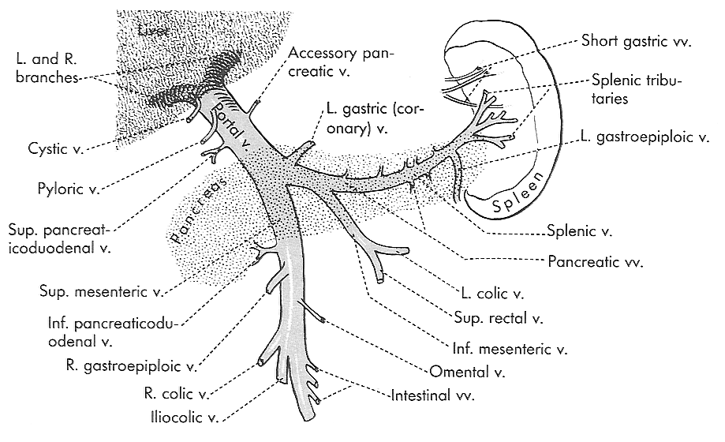
Autonomic Innervation of the Gut:

The body uses autonomic nerves to regulate those tissues that are better controlled involuntarily. This includes much of the abdominal viscera. Autonomic nerves consist of two neurons: presynaptic (or, preganglionic) and postsynaptic (or, postganglionic). Two separate autonomic systems can be defined anatomically. These are the sympathetic nerves (thoracolumbar outflow) and the parasympathetic nerves (craniosacral outflow).

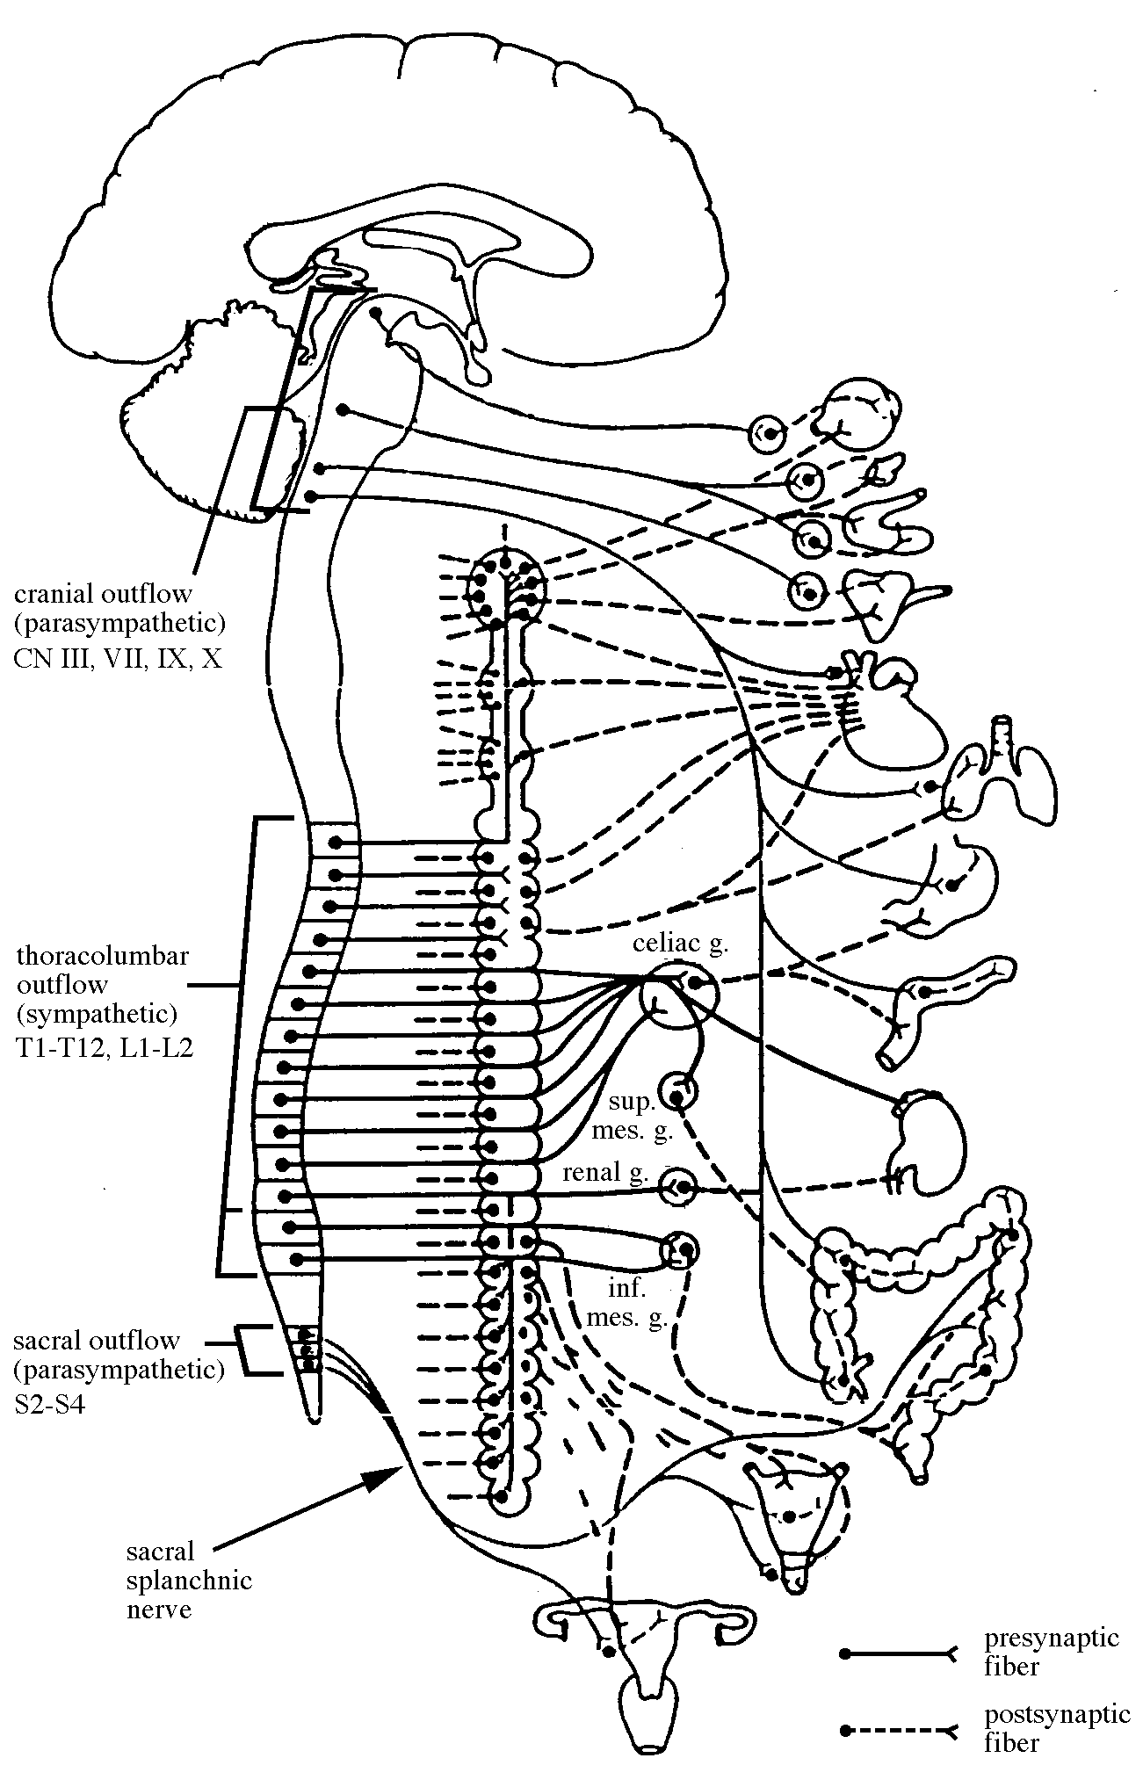

Sympathetic nerves primarily (but not exclusively) innervate blood vessels. They prepare the body for “fight or flight” reactions.

splanchnic nerves: bundles of autonomic presynaptic axons that pass directly through the sympathetic trunk in order to synapse at a site in the abdomen

thoracic splanchnic nerves (greater, lesser, and least): all composed of sympathetic presynaptic axons that penetrate the muscular diaphragm to enter the abdomen, where they finally synapse with postsynaptics at collateral ganglia. The thoracic splanchnics supply a majority of the sympathetic presynaptics for the abdominal viscera. Lumbar and sacral splanchnics exist, but are hard to identify in the cadaver. Sacral splanchnics are actually presynaptic parasympathetic fibers.

collateral ganglia: sites of collected sympathetic postsynaptic cell bodies lying outside the sympathetic trunks. These ganglia receive all presynaptics by way of the thoracic, lumbar and sacral splanchnics. They are located in the abdomen and pelvis, usually near the base of major arterial branches off the aorta, and are commonly named for the associated artery. You will see the celiac ganglion, superior mesenteric ganglion, and the inferior mesenteric ganglion.

extrinsic autonomic plexuses: mesh-like networks that serve the viscera. Parasympathetic fibers run in these plexuses, too. You will see the pulmonary plexus, the esophageal plexus, and several cardiac plexuses.

visceral afferent nerves: use the pathways described above for the sympathetics and parasympathetics, however, the impulse direction is toward the CNS (the opposite direction of true autonomic fibers).

Parasympathetic nerves (para = on either side [of the sympathetics]) principally supply the gut. Parasympathetic are particularly important in stimulating the digestive processes and in moderating the body after a time of great stress.

Vagus (CN X) nerve: Vagus = wanderer; is the only cranial nerve to send presynaptic, parasympathetic fibers to the neck and trunk. In the neck, thorax, abdomen, and pelvis the presynaptic-postsynaptic synapse is on or in the structure innervated. The vagus nerve is a cranial nerve that carries many parasympathetic axons out of the brain, most of which leave the nerve trunk to innervate viscera.

The presynaptic parasympathetic vagal fibers travel through the extrinsic autonomic plexuses described above. Postsynaptic cell bodies and axons contribute to the intrinsic plexuses in and on the wall of the structures served. Vagal parasympathetics innervate the laryngeal lining, tracheal lining, bronchi, pharyngeal lining, esophagus, heart, abdominal gut down to the descending colon, liver, gall bladder and ducts, and pancreas.

Parasympathetic fibers also leave the spinal cord at the sacral level. Sacral outflow parasympathetics use pelvic splanchnics to enter the inferior mesenteric and pelvic extrinsic autonomic plexuses. They innervate the descending colon, sigmoid colon, rectum, internal anal sphincter, urinary bladder and the erectile tissues of the external genitalia. Synapses occur at the enteric ganglia.

Clinical Manifestations:

Meckel’s diverticulum

Additional Suggested Readings:

Larsen, William J., Human Embryology, 2d ed. Churchill Livingstone Inc., New York (1997). Pages 229-258 (development of the GI tract).

Moore, Keith L. and T.V.N. Persaud, The Developing Human, 5th ed. W.B. Saunders Co., Philadelphia (1993). Pages 174-179 (the embryonic body cavity); 237-263 (the digestive system).

Study Questions:

1. Explain in terms of embryonic development why the hepatogastric ligament attaches to the lesser curvature of the stomach, whereas the gastrolienal ligament attaches along the greater curvature of the stomach.

2. Describe the blood supply and innervation to the anterior wall of the stomach and to the ascending colon. Does your familiarity with embryonic development help you to remember these details?

3. What is the function of the hepatic portal system? (Hint: Why is it important that blood from the gut is directed through the liver before returning to systemic circulation?) Where are other portal systems found? What is their function?

4. What is the embryological basis for Meckel’s diverticulum? Think about the possible clinical symptoms in a newborn. If the condition were not discovered until adulthood, how might the case present itself?

