THE HEART

Study Objectives: You are responsible to understand the basic structure of the four chambered heart, the position and structure of the valves, and the path of bloodflow through the heart. This handout lists all of the key terms that you should know in boldface type. Other terms you should know are listed below.

New Terms:

coelomic sac serosa mesentery
dorsal mesocardium pericardium fibrous pericardium
parietal serous pericardium parietal pericardium visceral serous pericardium
visceral pericardium epicardium pericardial cavity
right atrium crista terminalis auricle
musculi pectinate sinus venarum interatrial septum
fossa ovalis right ventricle conus arteriosus
trabeculae carneae septomarginal trabeculae moderator band
papillary muscles chordae tendinae tricuspid valve
pulmonary valve left atrium left ventricle
bicuspid (mitral) valve aortic valve superior vena cava inferior vena cava coronary sinus pulmonary trunkpulmonary arteries pulmonary veins aorta
right coronary artery marginal branch post. interventricular branch
left coronary artery ant. interventricular branch circumflex branch
great cardiac vein middle cardiac vein small cardiac vein
systole diastole SA node
AV node AV bundle (of His) Purkinje fibers
internodal fasciculi “lub-dup” cardiac plexus
myocardial ischemia angina infarction
murmur heart block pacemaker
bypass surgery

Structure--The Outer Layer:

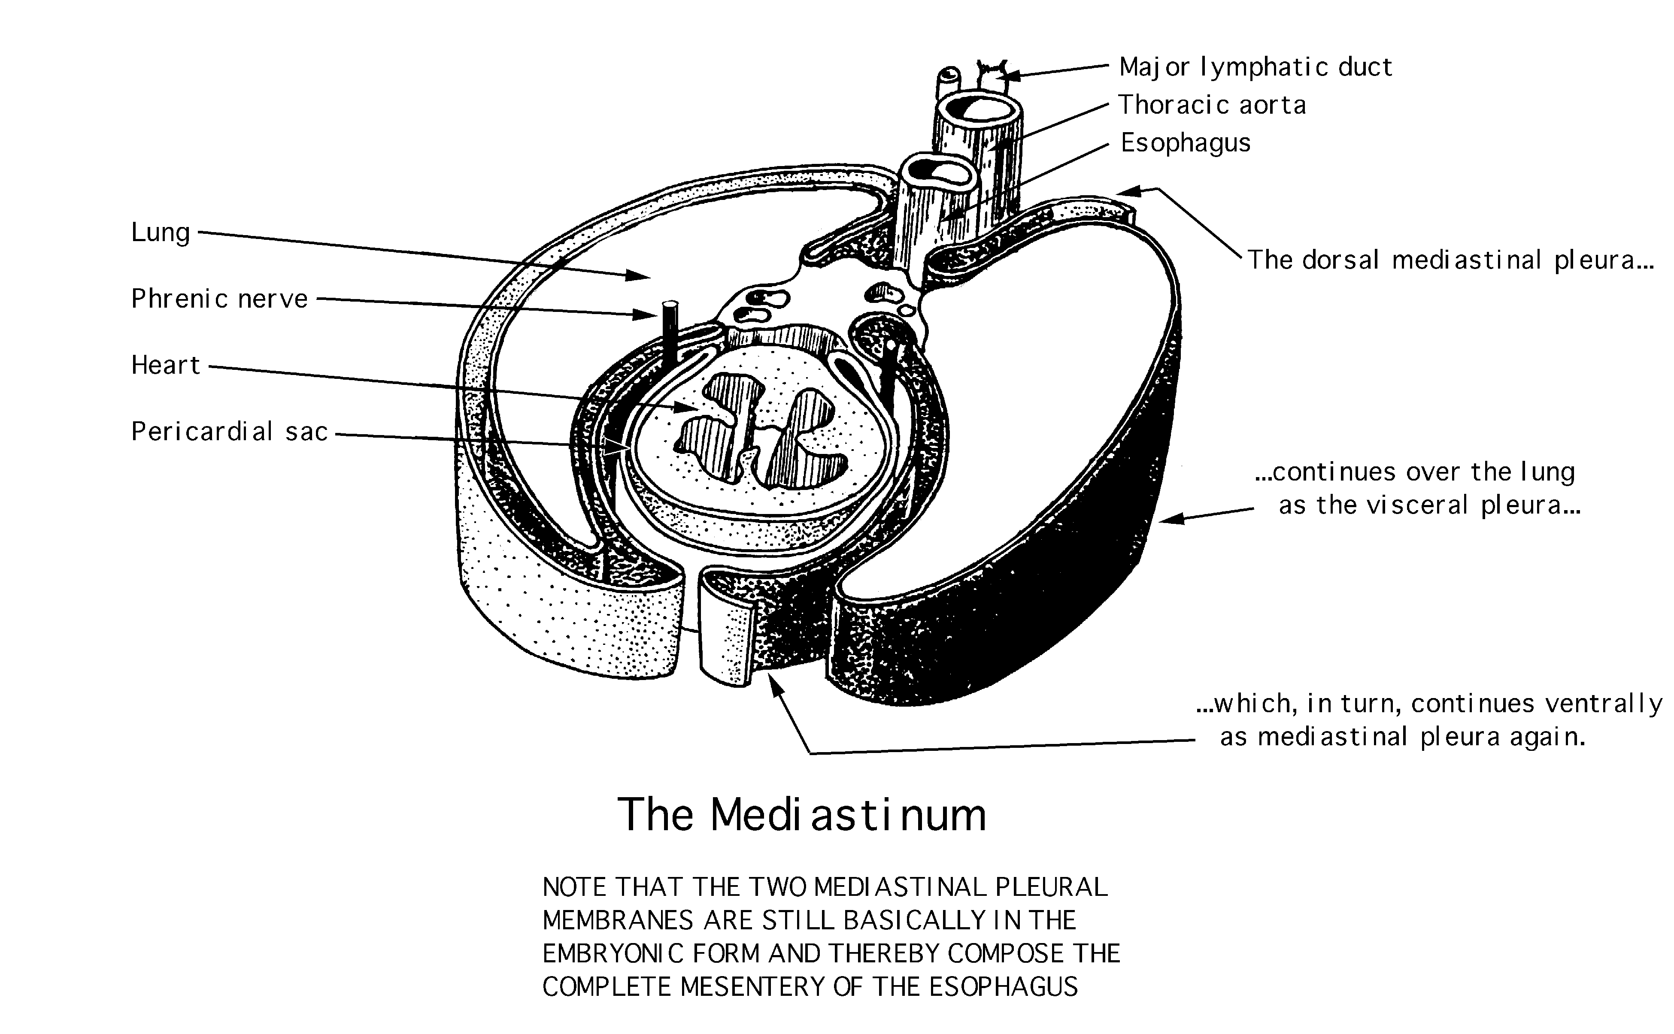

coelomic sac: in an adult, a closed, independent, mesothelium-lined sac. “Coelom” means cavity. Remember that a coelomic sac is always empty of other structures. Unless pathology is involved, the only thing that it may contain is a small of serous fluid.

serosa: the mesothelial membrane that lines the coelomic sac. No artery, nerve or other structure ever penetrates a serosa. Each serosa has a visceral and a parietal portion; they are continuous and classified according to position. Visceral serosa lie tightly against, and are hard to differentiate from, their associated organs. Parietal serosa are usually more fibrous and lie against the body wall.

mesentery: two intact, opposed serosal membranes that support a thoracic or abdominal organ (e.g., dorsal mesocardium, which forms the transverse pericardial sinus). Mesentery is usually named for the organ or part of the gut that it suspends.

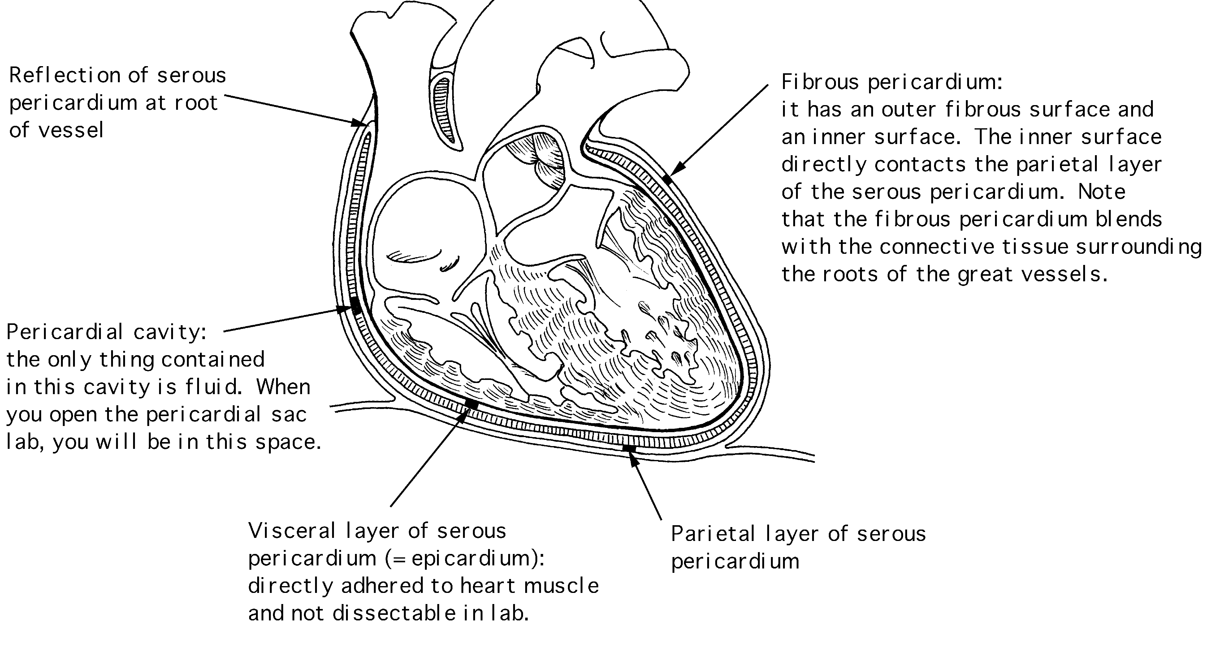

pericardium: a specialized name for the celomic sac that surrounds the heart.

fibrous pericardium: the most outer, fibrous layer of the pericardium.

serous pericardium: there are two surfaces (layers) to this tissue

parietal layer: the outer layer of the serosa surrounding the heart. Lines the fibrous pericardium, and the combination of the two layers is also called the parietal pericardium.

visceral layer: the inner layer of the serosa surrounding and adhering to the heart. Also called the visceral pericardium or epicardium.

pericardial cavity: the potential space between the parietal and visceral layers of the serous pericardium. The cavity is filled with serous fluid.

Structure--The Heart:

⇒Blood is delivered to the right atrium from the coronary sinus, inferior vena cava and superior vena cava

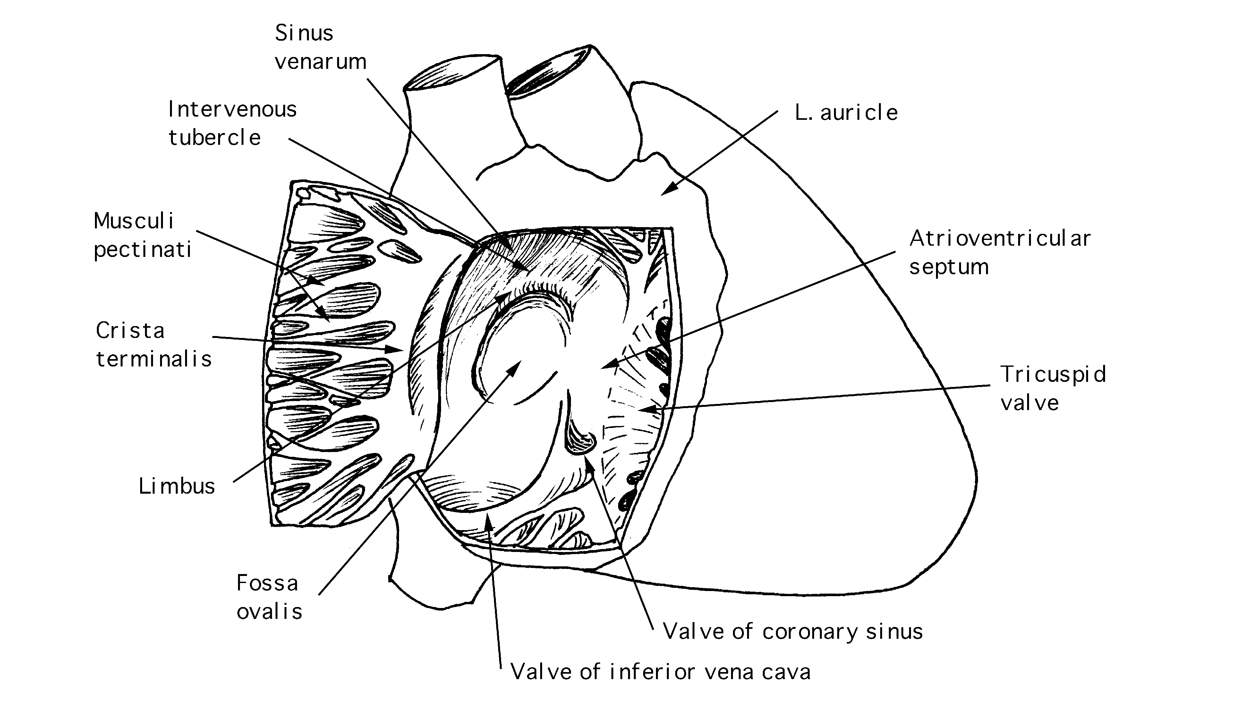

crista terminalis: separates the anterior rough-walled and posterior smooth-walled portions of the right atrium.

right auricle: small, conical, muscular, pouch-like appendage.

musculi pectinate (pectinate muscles): internal muscular ridges that fan out anteriorly from the crista terminalis. This portion of the right atrium corresponds to the primitive atrium of the embryonic heart.

sinus venarum: the smooth-walled cavity extending posteriorly from the crista terminalis.

interatrial septum: forms posteromedial wall of the right atrium.

fossa ovalis: located on the interatrial septum; a remnant of the fetal foramen ovale through which oxygenated blood from the placenta passed from the right atrium to the left atrium.

⇒ Blood travels to the right ventricle from the right atrium via the right atrioventricular valve

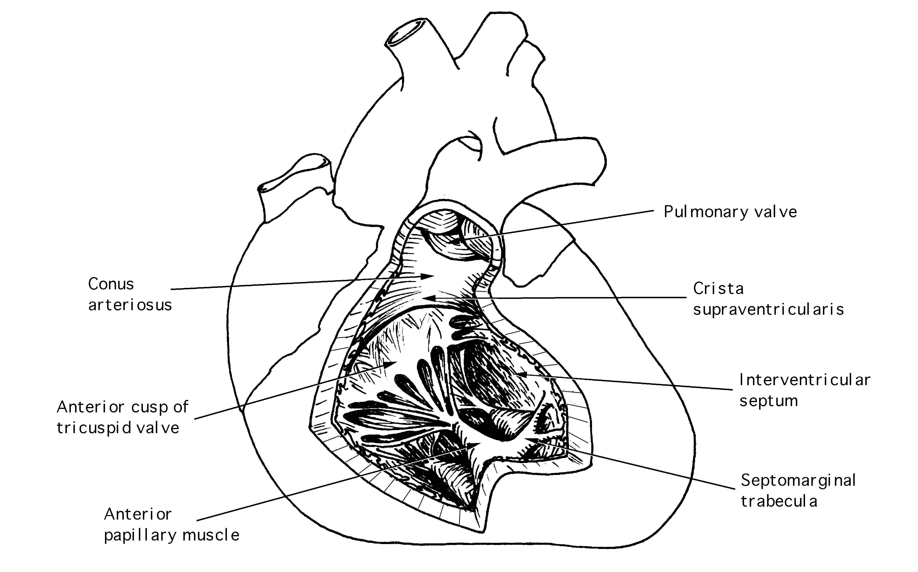

right ventricle: mainly dervied from the bulbis cordis; forms the largest part of the sternocostal surface of the heart. The walls are thicker than those of the right atrium.

conus arteriosus (infundibulum): superoanterior end of right ventricle tapers into this smooth-walled, cone-shaped structure that gives rise to the pulmonary trunk.

trabeculae carneae: muscle ridges and bulges lining the right ventricle (trabs=wooden, carneus=fleshy).

septomarginal trabeculae (moderator band): a trabeculae carneae, elevated into a free band, that crosses the cavity of the ventricle from the interventricular septum to the base of the anterior papillary muscle. It carries the right band of the AV bundle.

papillary muscles: irregular muscle bundles lining the wall of the ventricle except at the infundibulum. They connect the ventricular wall to the atrioventricular valve and are important in atriventricular valve integrity. The papillary muscles contract before the ventricle does.

anterior: largest papillary muscle; located on anterior wall and attached to anterior and posterior cusps of valve.

posterior: located on inferior wall and attached to posterior and septal cusps of valve.

septal: located on interventricular septal wall and attached to anterior and septal cusps of valve.

chordae tendinae: slender, fibrous threads that arise from apices of the papillary muscles. These insert into the free edges and ventricular surfaces of the valve cusps.

right atrioventricular (tricuspid) valve: located between the right atrium and right ventricle. This valve blocks the reflux of blood into the right atrium when the right ventricle contracts. The valve is formed by three fibrous cusps covered by endocardium and surrounded by a fibrous ring that provides attachment for the cusps.

pulmonary valve: lies at the apex of the conus arteriosus. It consists of three semilunar valve cusps that are concave when viewed superiorly. When the ventricle relaxes, these cusps open up like pockets to prevent the backflow of blood. The cusps are classified on their position in the fetal heart before rotation.

⇒ Blood leaves the heart via the pulmonary valve to the pulmonary trunk, is delivered to the lungs for oxygenation and returns via the pulmonary veins to the left atrium

left atrium: forms most of the base and posterior surface of the heart.

left auricle: pouch-like appendage of the left atrium, containing musculi pectinate.

pectinate muscles: found only in the auricle. The other walls of the atrium are smooth.

valvule of foramen ovale: functions as a valve in the fetal heart, preventing blood from flowing backward from the left atrium into the right atrium.

⇒ Blood travels from the left atrium to the left ventricle via the left atrioventricular valve

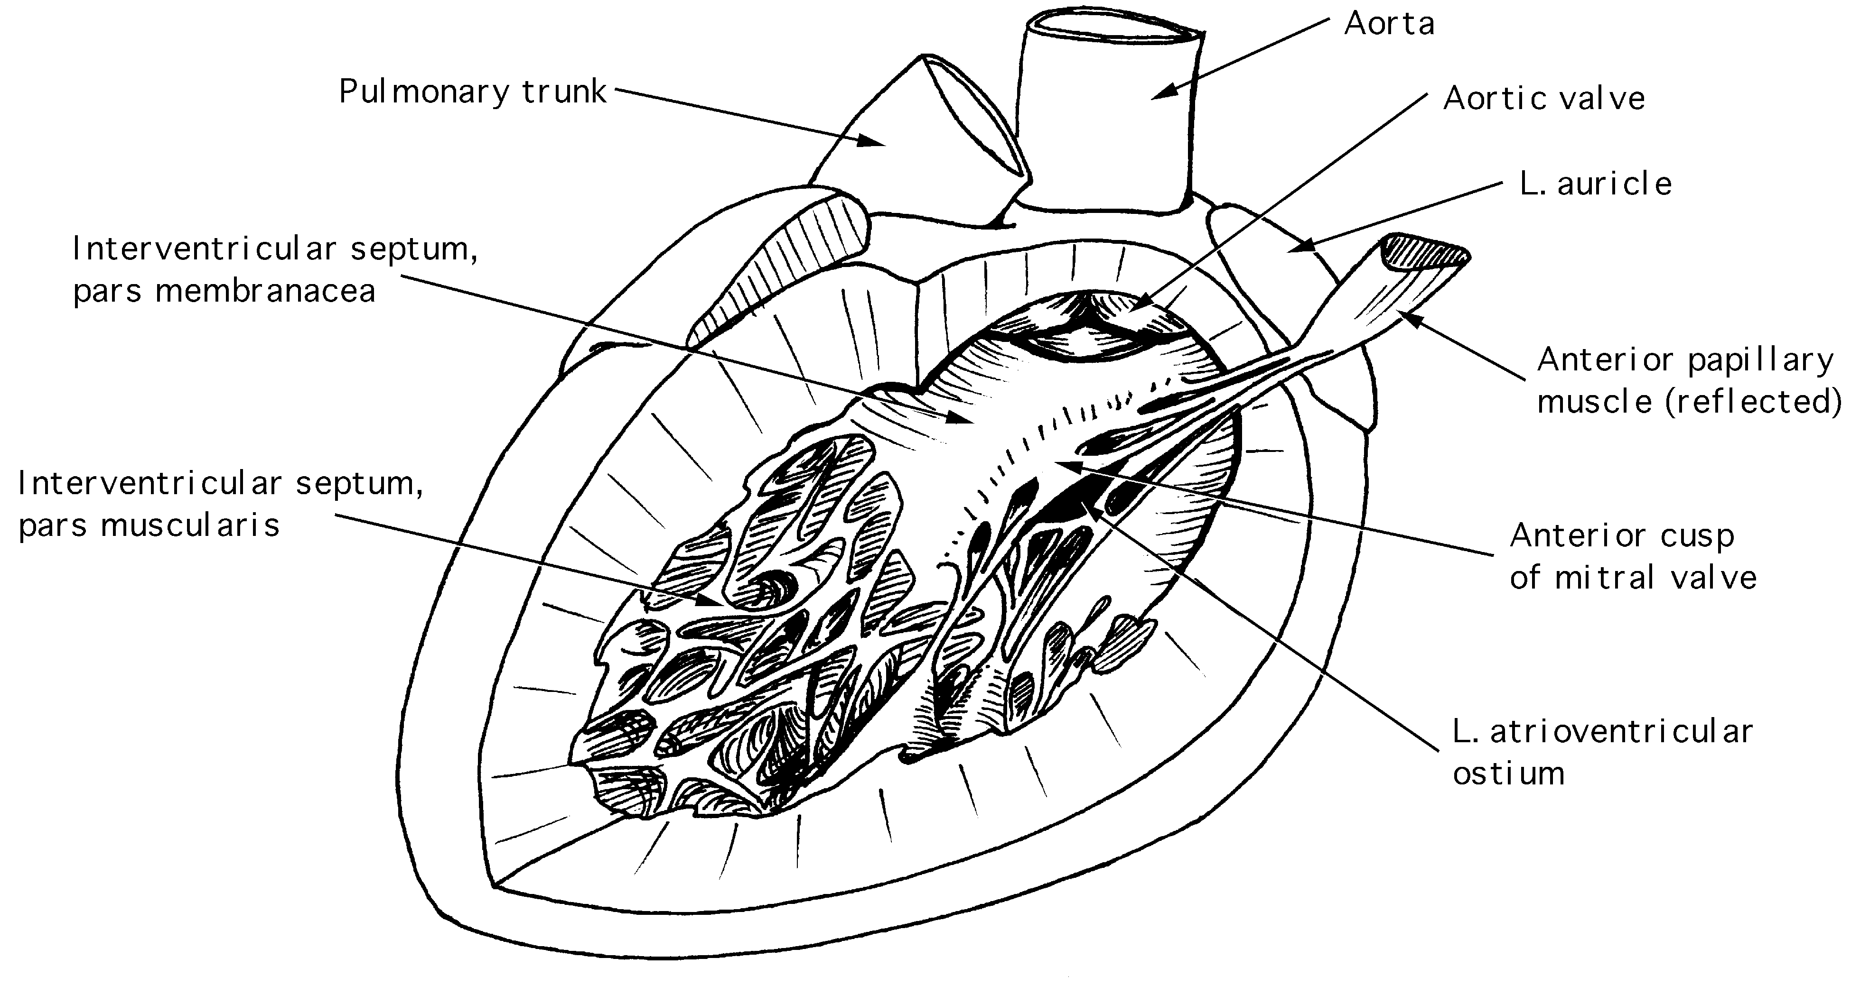

left ventricle: forms apex of the heart.

atrioventricular (mitral or bicuspid) valve: blocks the backflow of blood from the left ventricle into the left atrium. The valve is formed by two cusps, anterior and posterior. Of all the valves, the mitral valve is most frequently diseased.

trabeculae carneae: finer and more numerous that in the right ventricle.

papillary muscles: two large muscles, anterior and posterior, which are connected to the mitral valve.

chordae tendinae: thicker but less numerous than in the right ventricle.

aortic valve: similar in structure to the pulmonary valve, but its cusps are thicker. The right and left coronary arteries drain into two sinuses located in the concave spaces behind two of the cusps.

Blood Flow Sequence:

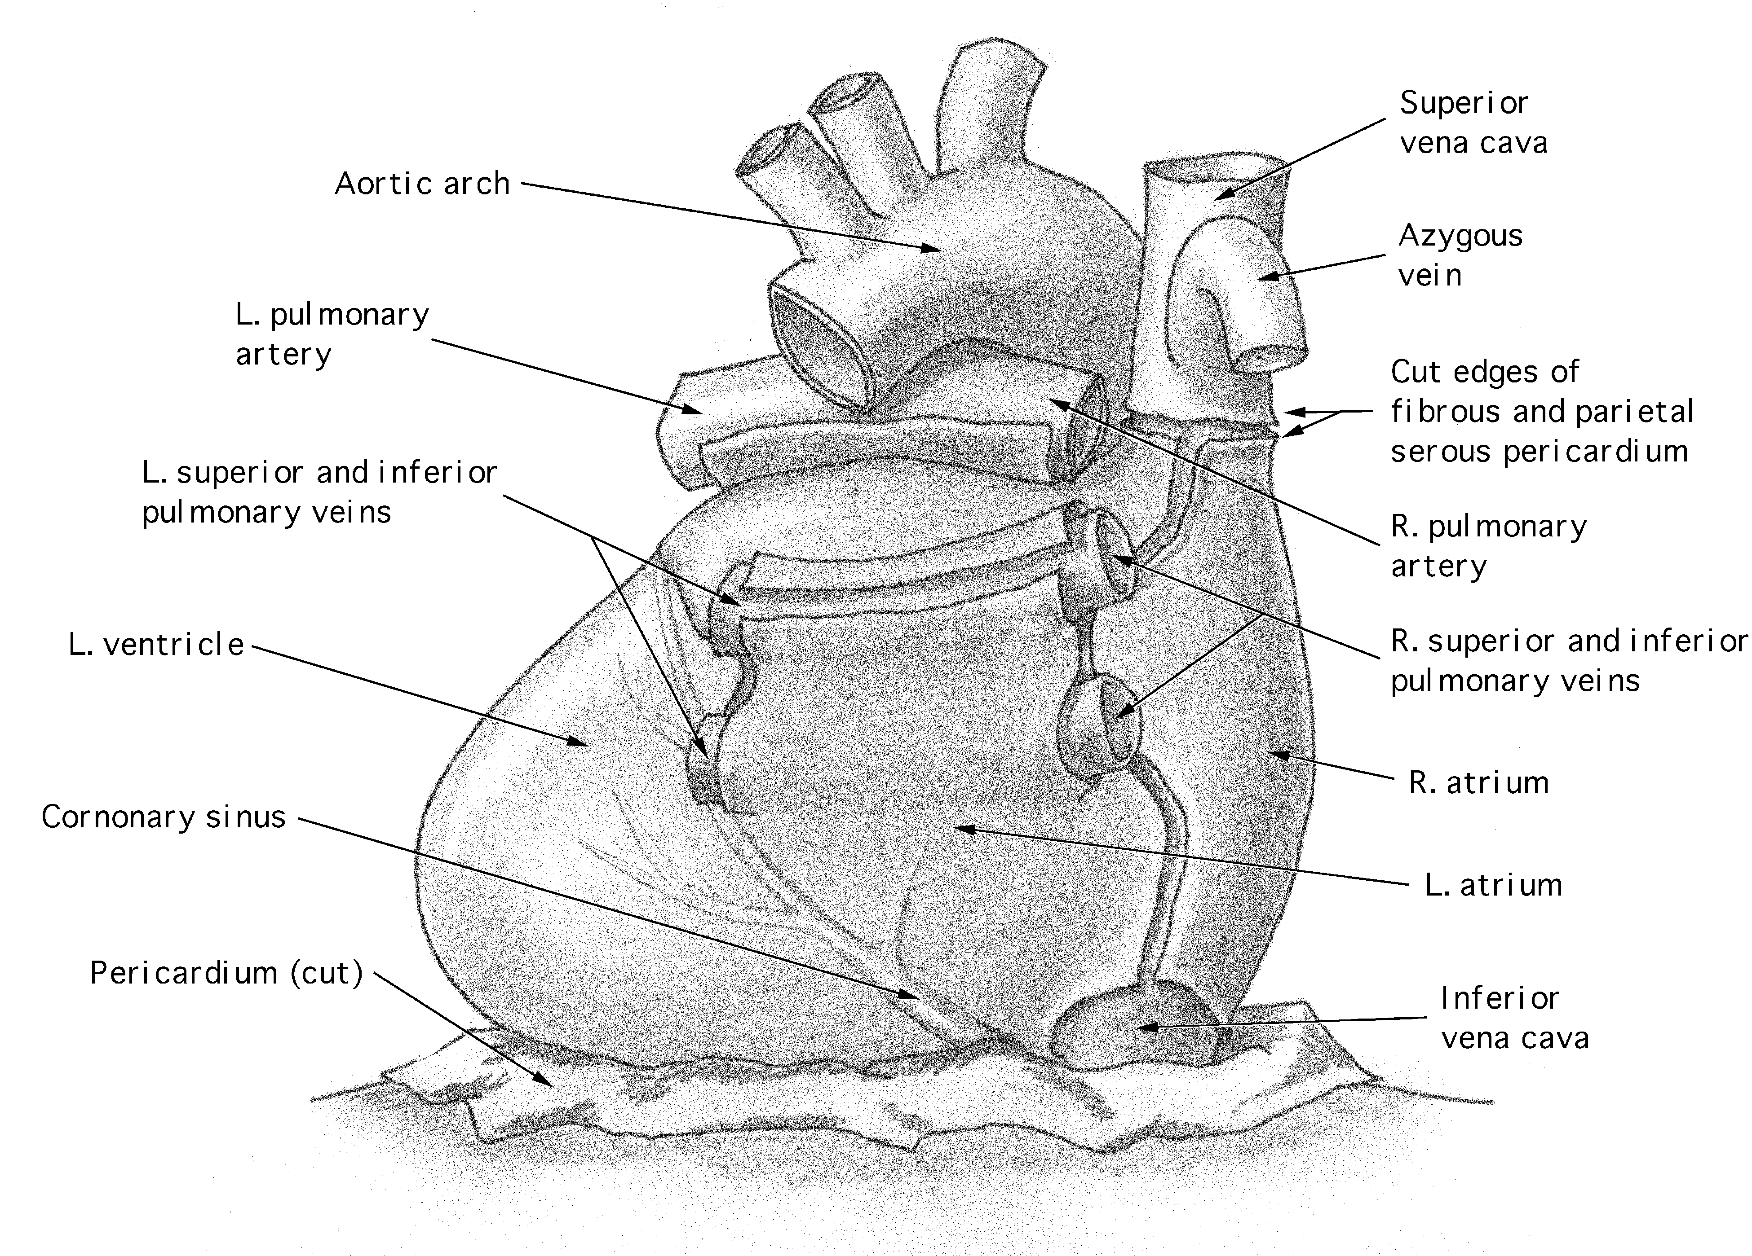

Superior vena cava (blood from arms, head, and thoracic wall), inferior vena cava (from lower body), and coronary sinus (from heart muscle) to

Right atrium, then through the tricuspid valve to

Right ventricle, then through the pulmonary semilunar valve to

Pulmonary trunk, which splits into the left and right pulmonary arteries which, in turn, carry the blood to the lungs

Oxygenated blood is returned from the lungs via paired left and right pulmonary veins which carry blood to

Left atrium, then through the bicuspid (or mitral) valve to

Left ventricle, then through the aortic semilunar valve to the aorta which arches over the pulmonary artery

Coronary Vessels:

You may have noted that the blood flow sequence given on the previous page does not provide a description of how blood is delivered to the heart. The following structures are the main vehicles of oxygenated blood transport to heart muscle and de-oxygenated blood transport back to the right atrium.

Coronary arteries: deliver oxygenated blood to the myocardium. They arise from the aorta just above its origin from the left ventricle. Note that coronary vessels are extremely variable.

right coronary artery: originates on the right side of the aorta and passes to the right behind the pulmonary trunk to run down the coronary sulcus. It supplies blood to the right ventricle and right atrium.

marginal branch: descends toward the apex along the right margin, supplying most of the anterior wall of the right ventricle.

posterior interventricular branch: runs in the posterior interventricular sulcus toward the apex, supplying the diaphragmatic surface of both ventricles and one-third of the interventricular septum.

left coronary artery: branches almost immediately.

anterior interventricular branch: descends toward the apex in the anterior interventricular sulcus, supplying the anterior portions of both ventricles and two-thirds of the interventricular septum.

circumflex branch: runs to the left and circles posteriorly where it will often anastomose with the right coronary artery.

Cardiac veins: most of the venous blood is collected from the myocardium by veins that parallel the arteries. The veins drain into the coronary sinus that empties into the right atrium.

great cardiac vein: lies in the anterior interventricular sulcus and drains upward alongside the anterior interventricular branch of the left coronary artery.

middle cardiac vein: runs in the posterior interventricular sulcus.

small cardiac vein: runs in the coronary sulcus alongside the right coronary artery.

Cardiac cycle:

This is the series of changes that take place within the muscular pump of the heart as it fills with blood and empties. Marked by two heart sounds that follow each other in quick succession and are separated from the next doublet by a longer interval. During this interval the ventricles are contracted. The sounds are caused first by the closing of atrioventricular valves and then by the closing of the semilunar valves.

Systole = contraction

Diastole = relaxation

On principle, blood flows passively into the right and left atria. When ventricular diastole occurs, the AV valves open allowing blood to pass from atria to ventricles; when ventricular systole occurs, the AV valves are closed.

Blood flows from atria to ventricles. The SA node initiates the wave of contraction in the atria (atrial systole). This helps to empty the contents of the atria into the ventricles. The cardiac impulse reaches the AV node and is conducted to the papillary muscles by the AV bundle. The papillary muscles contract, pull on the chordae tendinae holding the cusps of the AV valves in place. The spread of the cardiac impulse from the AV bundle to the Perkinje fibers causes contraction of the ventricles. Increased pressure in the ventricles causes the atrioventricular valves to close and their connection with the already contracted papillary muscles via the chorda tendinae prevents cusp eversion and consequent reflux of blood into the atria. The sound of the closing of the atrioventricular valves, “lub”, marks the beginning of ventricular systole.

During ventricular systole when the intraventricular blood pressure exceeds that in the large arteries, the cusps of the pulmonary and aortic valves are pushed aside, and blood is ejected from the heart.

As the ventricular myocardium relaxes, blood moves back toward the ventricles, filling the pockets of the semilunar valves and causing them to float into apposition blocking the pulmonary and aortic orifices. The sound made by closing of the aortic and pulmonary valves, “dup”, marks the beginning of ventricular diastole.

 | lub | dup | lub | dup
AV valves | closed | open | closed | open
pulmonary and  aortic valves | open | closed | open | closed
ventricles | contract | relax | contract | relax

Innervation and Conduction System:

efferent (motor) nerve impulses: influence the pacemaker and coronary blood flow. Efferent parasympathetic (vagus nerve) impulses slow the heartbeat and constrict arteries. Efferent sympathetic impulses increase speed and intensity of heart beat and dilates vessels.

afferent (sensory) nerve impulses: concerned with reflex adjustments of heart beat, circulation, respiration and mediation of cardiac pain. Afferent parasympathetic (vagus) nerves carry cardiac reflexes and sense changes in pressure and oxygen level. Afferent sympathetic nerves conduct pain sensations from the heart. Note that parietal pericardial pain is mediated by somatic afferent nerves (phrenic). The epicardium is insensitive to pain.

cardiac plexus: Sympathetic and parasympathetic nerves commingle in this plexus located anterior to the tracheal bifurcation. The plexus includes fibers from the vagus nerve (parasympathetic) and three cardiac branches from the sympathetic trunk. Nerves travel to the heart along the coronary arteries and modify the rate and strength of the heart beat.

The conduction system consists of specialized heart muscle fibers that transmit electrical impulses to regulate atrial and ventricular contraction. These modified fibers are separated from the ordinary myocardial fibers by delicate envelopes of connective tissue. They have a power of spontaneous rhythmicity and conduction more highly developed than the rest of the heart. The conduction system initiates and superimposes a rhythm with a rapid rate that it transmits to all parts of the heart and which can be regulated by the nervous system. The ventricles and atria also have innate powers of spontaneous contraction, independent of any nervous influence.

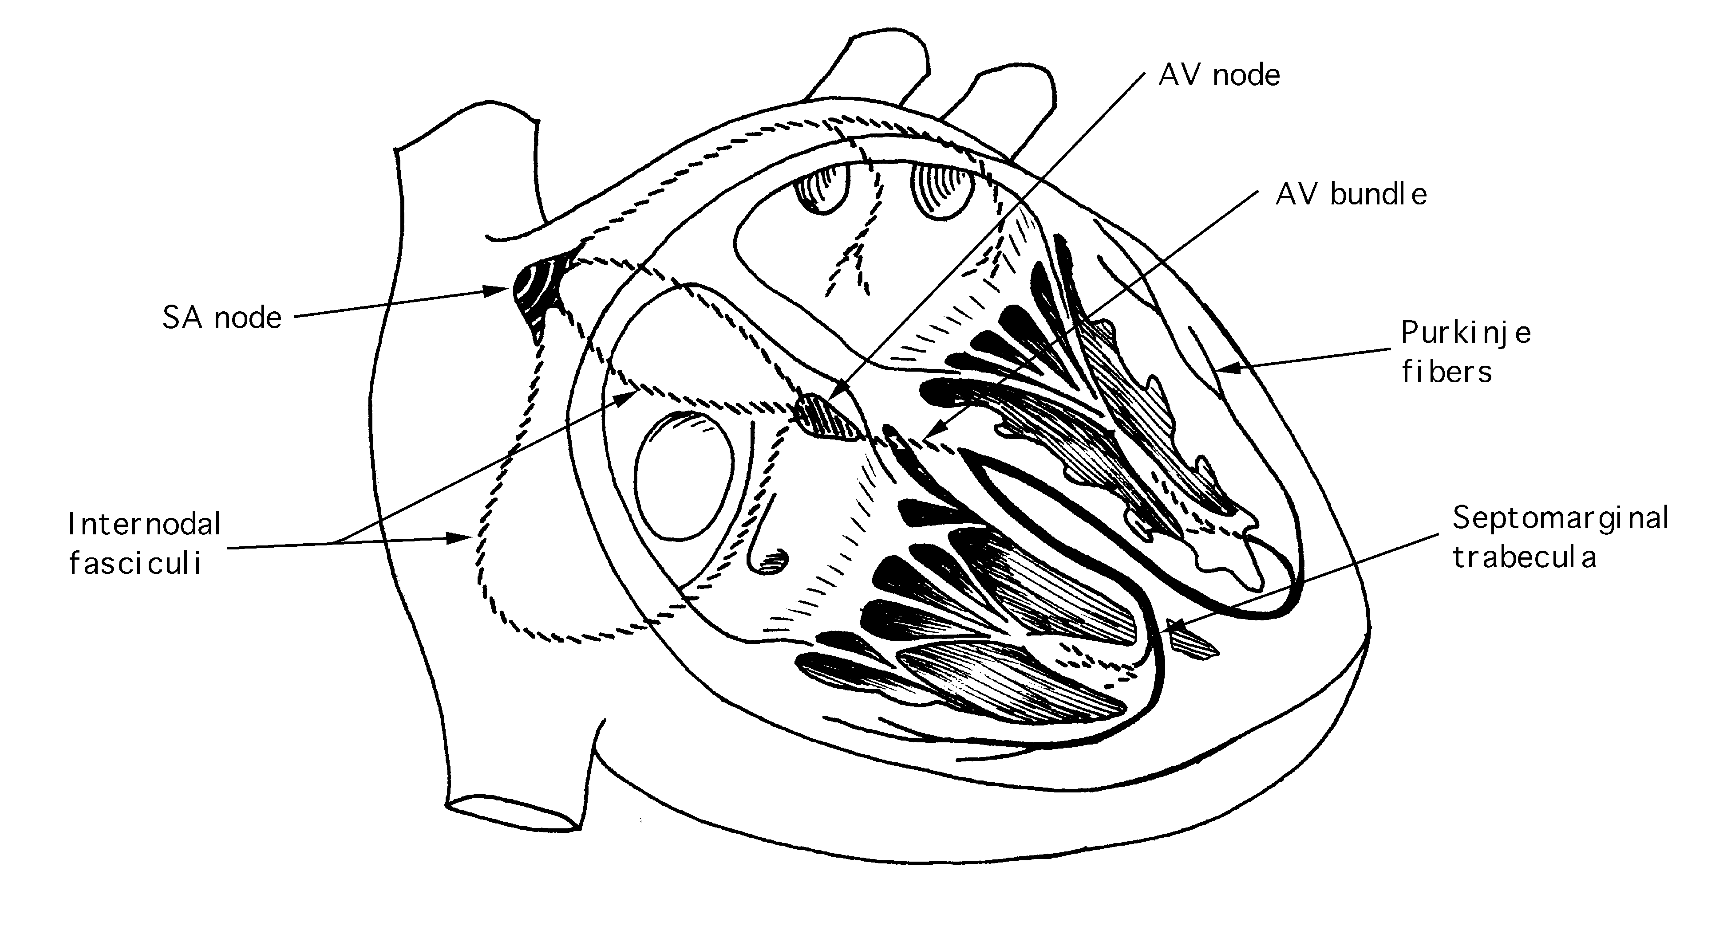
sinuatrial (SA) node: generates impulses that spread to the AV node uniformly through the atrial myocardium.

atrioventricular (AV) node: located in interatrial septum.

atrioventricular bundle (of His): responsible for activation of ventricular contraction. Note that the fibers of the conduction system are the only myocardial connection between the atria and the ventricles.

left and right septal (bundle) branches: located in the septomarginal trabecula.

Purkinje fibers: fasciculi from the septal branches spread out as subendocardial Purkinje fibers over the ventricular wall and papillary muscles and are continuous with ventricular myocardial fibers.

Clinical Definitions:

myocardial ischemia: insufficient oxygen supply to heart muscle from coronary artery spasm or occlusion from atherosclerosis, etc.

angina: pain in chest which radiates down arm; results from ischemia.

infarction: death of heart muscle from severe ischemia – a “heart attack”.

murmur: sound of blood under high pressure passing through a small hole, such as a valve defect.

heart block: dissociates the contraction of atria and ventricles. The ventricles beat at a slower rate.

pacemaker: implantation of electrode into the ventricle connected to an electronic pacemaker that will deliver appropriate rhythmic shocks to the heart.

bypass surgery: segments of coronary arteries which are occluded by plaque deposits are “bypassed” with segments of greater saphenous vein or by anastomosis of internal thoracic artery past the occlusion.

heart sounds: the sounds of closing atrioventricular (bicuspid and tricuspid) valves “lub”, followed by the sound of closing semilunar valves “dup”.

Laboratory Dissection:

Practice reorienting the dissociated heart and identifying anatomical features of the heart from different angles. Know the orientation of the heart in anatomical position.

During dissection, look for the following features:

clots of blood
pericardial and epicardial fat
diseased, damaged or artificial valves
evidence of bypass surgery
variation in size

Additional Suggested Readings:

Hollingshead, W. Henry and Cornelius Rosse, Textbook of Anatomy, 4th ed. Harper & Row, Philadelphia (1985). Pages 71-92 (circulatory system).

Langebartel, D.A. The Anatomical Primer. University Park Press, Baltimore (1977). Especially for coelomic sacs and mesenteries.

Study Questions:

1. Following a massive drug overdose a woman receives an injections of adrenaline directly to her heart muscle using a very large needle and syringe. Identify in order the layers and spaces that the needle passes through.

2. Describe (without benefit of notes) the path of blood from an intercostal vein back to an intercostal artery (through the heart to the lungs, and from the lungs back out into the system).

3. Describe the various mechanisms (2) preventing backflow of blood as it moves through the heart.

4. If the marginal branch of the right coronary artery becomes blocked, which chamber of the heart will be primarily affected?

5. What connects the atria to the ventricles?

