DEVELOPMENT OF THE HEART

Study Objectives: This lecture should provide you with a basic understanding of the stages of heart development, from the appearance of the endocardial tubes through changes occurring at parturition. You will also gain knowledge of fetal circulation, how it differs from that of the newborn, and the anatomical basis for these differences. The purpose of this lecture is to provide you with a developmental perspective of cardiac anatomy that will help you to understand and appreciate newborn and adult anatomy. Aspects of development that are involved in abnormalities resulting in common clinical manifestations will be noted. You should also understand fetal circulation and be able to identify the remnants of fetal circulation in the adult body.

New Terms:

cardiogenic cords endocardial tubes coelomic sac
serosa pericardial sac mesentery
dorsal mesocardium transverse sinus cardiac jelly
vitelline veins umbilical veins common cardinal veins
intersegmental arteries vitelline veins umbilical arteries
heart tube bulbus cordis truncus arteriosus
conus arteriosus atrium (pl. = atria) ventricle
sinus venosus aorticopulmonary septae valve
septum primum septum secundum interventricular septum
foramen ovale foramen primum foramen secundum
interventricular foramen ductus arteriosus ligamentum arteriosum
septum transversum ductus venosus ligamentum venosum
shunt pulmonary arteries pulmonary veins
atrial septal defect (ASD) patent ductus arteriosus angiogenesis
sinus (>1 meaning) ligament (>1 meaning) ligamentum teres
visceral parietal

The cardiovascular system is the first system to function in the embryo. It is functioning by the end of the third week of development. You will learn in the heart lecture that the heart has a nervous system all its own known as the conduction system. Cells that make up the conduction system have a very highly developed power of spontaneous rhythmicity and conduction that is more highly developed than in the rest of the heart. However, the ventricles and the atria have innate powers of spontaneous contractility independent of any nervous influence. We know this because the fetal heart is beating before the conduction system or the nervous system is established, because isolated cardiac cells contract rhythmically when viewed in culture, and from the observation that the human heart continues to beat even when removed from the body (as in heart transplant operations).

The first sign of heart development is the formation of cardiogenic cords. These are canalized to form two endocardial tubes that fuse to make one heart tube. Before we look at the development of the heart in detail, we will look at the development of the pericardial cavity.

Pericardial Cavity:

Coelomic sacs in the adult are closed, independent, mesothelial-lined sacs of the trunk, and under normal (non-pathological) circumstances, they are empty except for a very small amount of lubricating fluid that allows the surfaces to move against one another without friction. This is important because dissection of those organs that develop adjacent to coelomic sacs (lungs, heart, abdominal viscera) might give you the illusion that these organs develop within the sacs. The organs are actually pushed into the lining of the related sac in a way that can be remembered by the image of pushing a fist into an inflated balloon. The fist represents the organ and the balloon represents the coelomic sac. Notice that the coelomic sac (balloon) is empty.

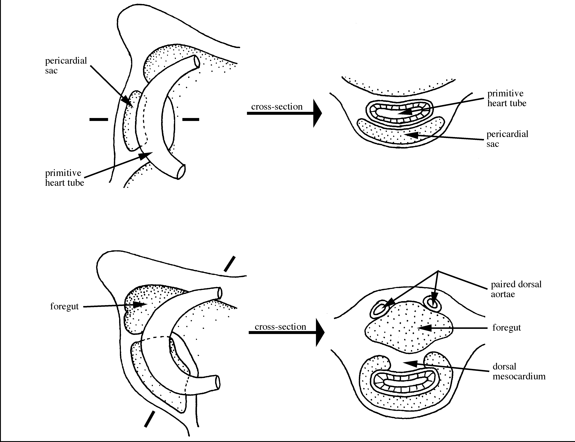

All coelomic sacs can be described as a cavity lined by a mesothelial membrane called a serosa. It is the internal serosal surface that produces a serous fluid and enables opposing serous membranes to slide across one another. The coelomic sac that surrounds the heart during its development is known as the pericardial sac.

A mesentery consists of two intact, opposed serous membranes that support a thoracic or abdominal organ. Mesenteries are usually named for the organ that they suspend. The mesentery relevant to heart development is the dorsal mesocardium (meso = mesentery, cardium = heart). The heart pushes into the dorsal wall of the pericardial sac during development. As the heart pushes into this empty sac, it becomes surrounded to such a degree that two layers of the dorsal tissue become opposed and are given the name, the dorsal mesocardium. The dorsal mesocardium suspends the heart for a time but soon breaks down leaving the heart suspended at its cranial and caudal surfaces but not at the back. The gap which persists where the dorsal mesocardium once was is called the transverse sinus. You will explore this space in gross dissection laboratory. The heart tissue is still encased by the visceral layer of pericardium and the parietal layer surrounds it. All that has disintegrated is the dorsal mesocardium. More will be said about the details of the anatomy of the adult pericardial sac in the lecture on the heart.

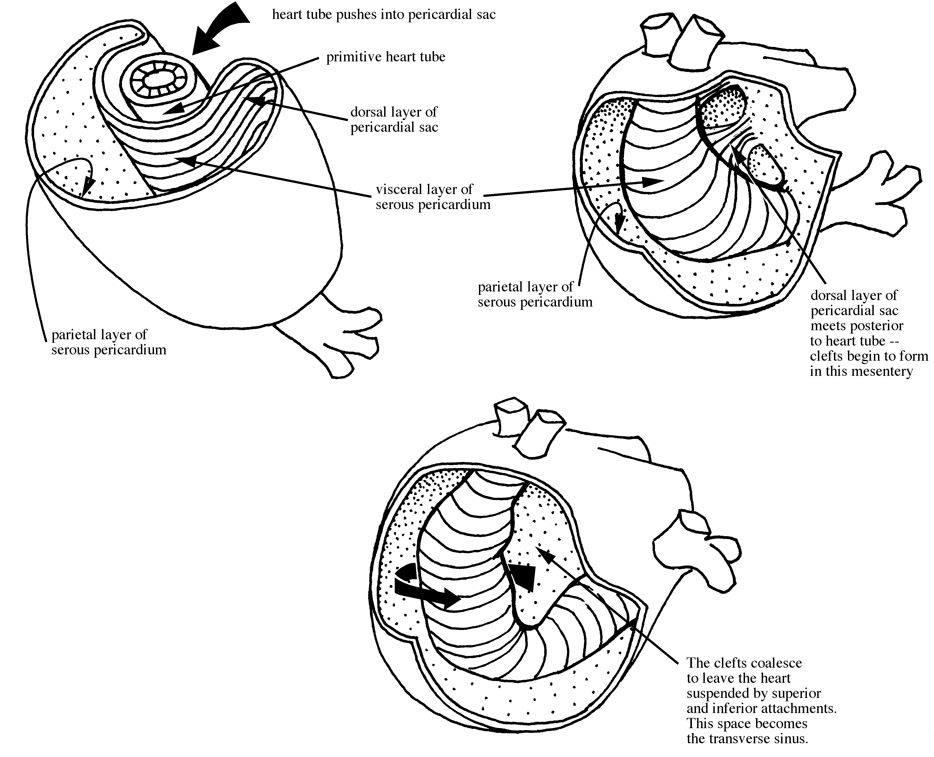
Early Development of the Heart:

Endocardial tubes (Day 19): These thin-walled, endothelial tubes develop from condensations of splanchnopleuric mesoderm in the cardiogenic region of the trilaminar germ disc. The cardiogenic region is cranial to the neural plate.

Embryonic folding (begins Day 20): Lateral and cephalic folding of the trilaminar germ disc over the course of several days brings the endocardial tubes together and tucks them ventrally in the thoracic region at the base of the yolk sac. This process also brings the septum transversum into its adult position inferior to the heart.

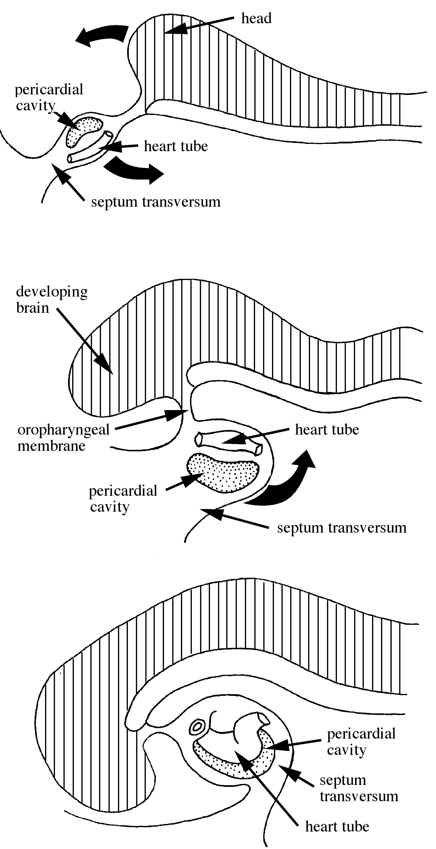

Primary heart tube (Day 21): The endocardial tubes fuse together into a primary heart tube through which blood eventually flows in a cranial direction. The mesenchyme surrounding the tube condenses to form the myoepicardial mantle (the future myocardium). Gelatinous connective tissue called cardiac jelly separates this mantle from the endothelial heart tube (the future endocardium). In addition, a series of constrictions (sulci) divide the heart tube into sections: sinus venosus, into which the common cardinal veins, the umbilical veins and the vitelline veins drain; the primitive common atrium; the primitive ventricle; and the bulbus cordis, through which blood flows to the paired dorsal aortae. The heart is beating at Day 22. Contractions are of myocardic origin and are likened to peristalsis. Several processes that are not restricted to the heart proper continue to occur during this time that have a great impact on heart development: embryonic head folding, embryonic lateral folding, and elongation of the heart tube in an increasingly restricted space.

Looping of heart tube (Days 23-28): The primitive atrium loops up behind and above the primitive ventricle and behind and to the left of the bulbus cordis. Blood begins to circulate through the embryo by Day 24. The looping process brings the primitive areas of the heart into the proper spatial relationship for development of the adult heart.

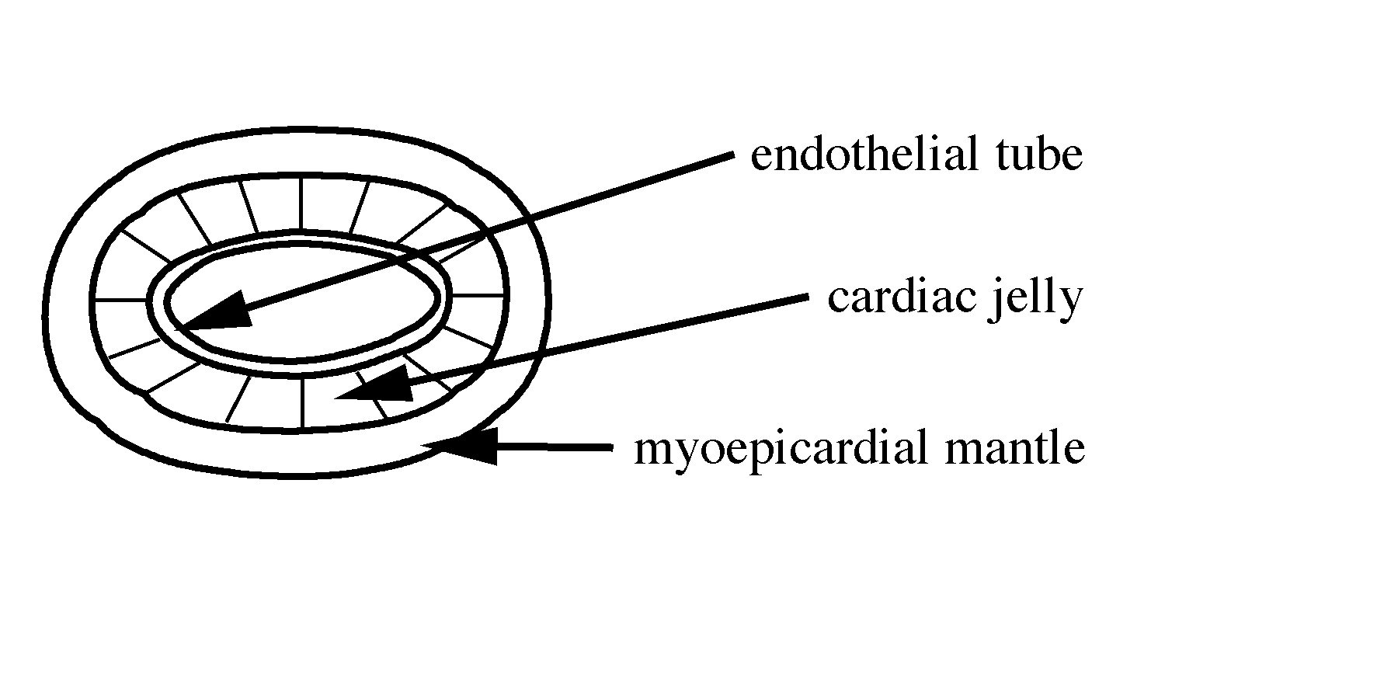

Circulation at 22 Days:
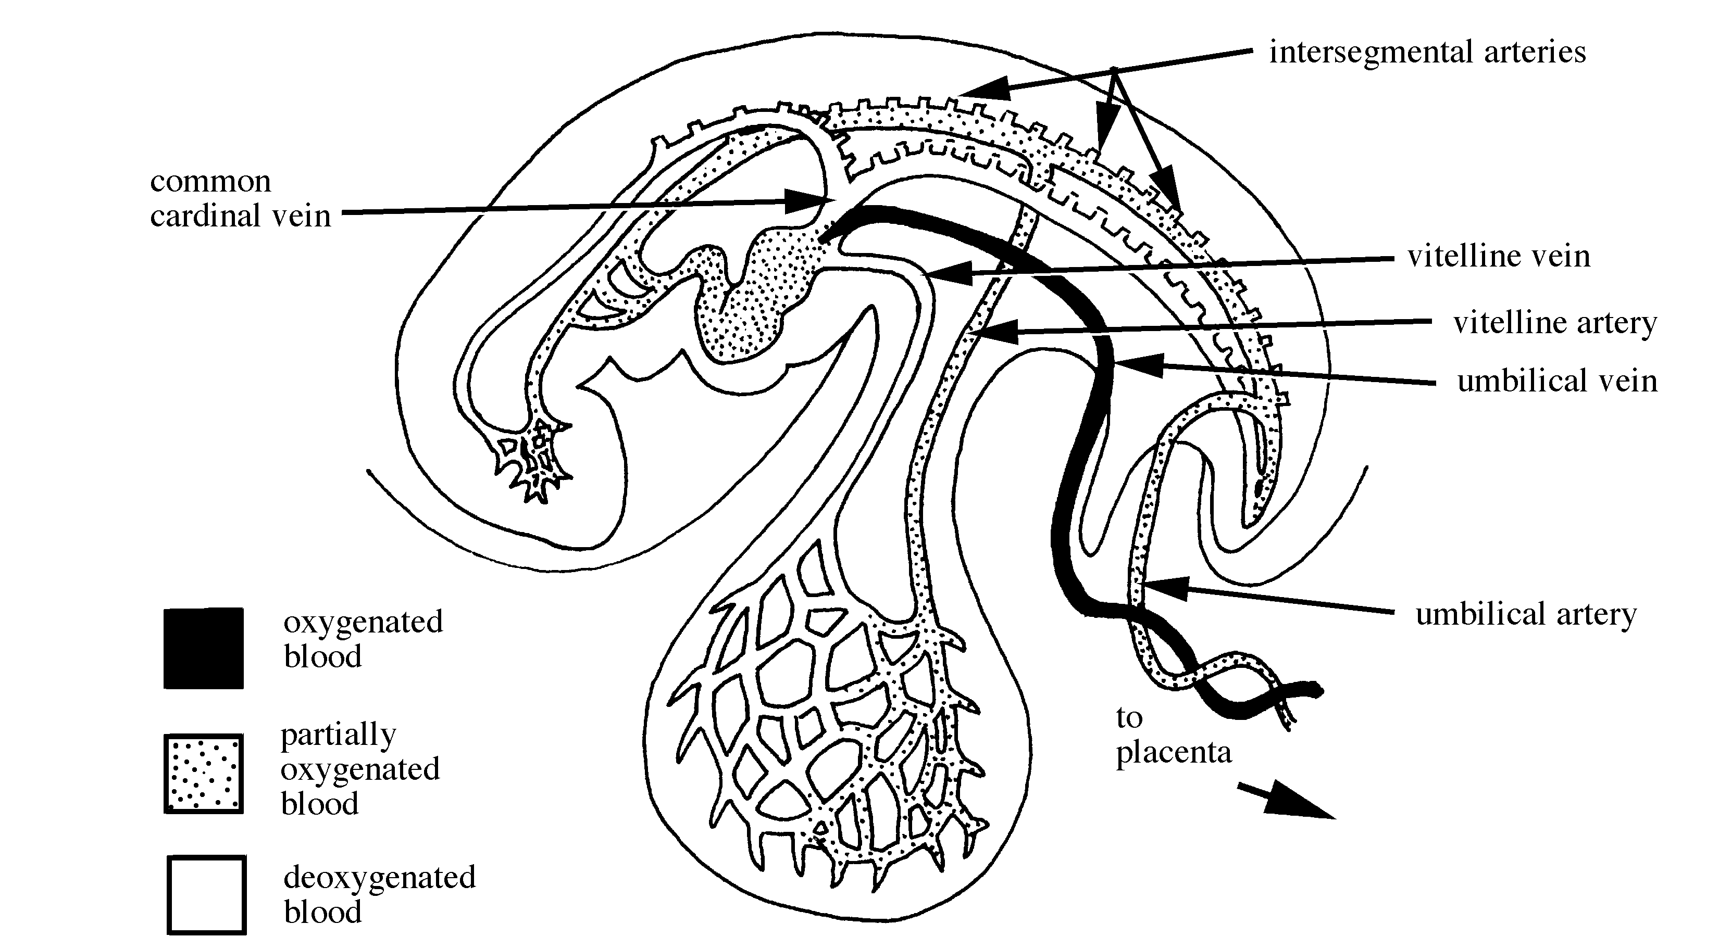

Three paired veins drain into the heart of the embryo during the fourth week:

Vitelline veins drain blood from the yolk sac; their formation has associations with formation of the liver and the portal system.

Umbilical veins bring oxygenated blood from the chorion (early placenta). There are two at the start. The right umbilical vein degenerates and disappears. The left umbilical vein persists, carrying all blood from the placenta to the fetus. The umbilical vein degenerates after it is cut at birth and is viewed in the adult cadaver as ligamentum teres.

Common cardinal veins return blood to the heart from the body of the embryo. The derivation of the adult structures from the cardinal veins are complex but produce: the left brachiocephalic v., the azygous v., the common iliac v., the left renal v., the suprarenal v., the hemiazygous v. and the IVC.

Three sets of paired arteries are evident in the embryo. The first two carry blood to portions of the developing organism while the third carries blood away from the organism to the placenta.

The intersegmental arteries form 30-35 branches off the dorsal aortae. Many of these are transient structures, but some persist to form the vertebral a., the intercostal a., and the common iliac a. See Larsen (pp. 193-204) for a good discussion of arterial development.

The vitelline arteries pass to the yolk sac and later to the primitive gut which forms from the yolk sac. Three of the vitelline arteries remain that provide blood to the gut in the adult. These include: the celiac artery, the superior mesenteric artery and the inferior mesenteric artery. The vitelline system becomes the portal system of the adult. You will become intimately acquainted with this system during your dissection of the gut.

The umbilical arteries carry oxygen-depleted blood to the placenta. The proximal parts of these arteries become the internal iliac arteries and the superior vesical arteries but the distal parts break down after birth and become the medial umbilical ligaments.
Formation of Heart Chambers:

Right atrium: As the heart continues to grow, the right side of the sinus venosus is incorporated into the right side of the primitive atrium. The primitive atrial wall is pushed ventrally, eventually becoming the right auricle. In the adult heart, the right auricle contains pectinate muscle derived from the primitive atrium, whereas the sinus venarum is derived from the sinus venosus and therefore smooth-walled.

Left atrium: The left side of the primitive atrium sprouts a pulmonary vein which branches and sends two veins toward each of the developing lungs. The trunk of this pulmonary vein is incorporated into the left side of the primitive atrium, forming the smooth wall of the adult left atrium. The left side of the primitive atrium is pushed forward and eventually becomes the trabeculated left auricle.

Interatrial septum: The interatrial septum in the adult heart is formed by the combination of two embryonic septa: the septum primum and the septum secundum. The septum primum grows along the midsagittal plane like a waxing moon toward the atrioventricular canal. This septum separates the two atria, except for a temporary space at the posteroinferior edge of the septum primum called the foramen primum which permits the right-to-left shunt of fetal blood. At the superior edge of the septum primum clefts begin to form that provide a second opening, the foramen secundum. The foramen secundum provides an alternate right-to-left shunt, and the foramen primum closes. During this process a second, partial septa, the septum secundum, also begins to grow down from the roof of the right atrium, just lateral to the septum primum. The septum secundum is thicker and more muscular than the membranous septum primum and permits the right-to-left shunt of blood through a space called the foramen ovale. The septum secundum eventually fuses inferiorly, but foramen ovale remains patent enabling the shunting of blood from the right to left side of the heart. Fetal blood is shunted from the right atrium to the left atrium through two staggered openings: the foramen ovale and the foramen secundum. After birth, when pulmonary circulation increases blood pressure in the left atrium, the membranous septum primum is pressed against the septum secundum. They eventually fuse and block the right-to-left shunt of blood. (See Fig. 14-12 in Moore and Persaud).

Interventricular septum: The left ventricle is formed primarily from the primitive ventricle. The right ventricle is formed primarily from the bulbus cordis. The superior portion of the bulbus cordis becomes the conus arteriosus and the truncus arteriosus. A muscular interventricular septum begins to grow superiorly from the ventricular floor between the presumptive right and left ventricles. This septum stops short of the atrioventricular canal, leaving a space called the interventricular foramen which permits blood from both ventricles to exit via the conus arteriosus. Within the conus arteriosus, spiral aorticopulmonary septae form, dividing the conus in half and extending inferiorly to fuse with and complete the interventricular septum. These septae continue superiorly into the truncus arteriosus, creating outflow tracks from the right and left ventricles that are the vestigial pulmonary trunk and aorta.

Fetal Circulation:

The developing circulatory system acts to bring oxygenated blood from the placenta through the umbilicus, distribute it throughout the fetal system, and return oxygen-depleted blood to the placenta. After birth, portions of this path become obsolete, but these vessels remain apparent in the adult body as thickened strands of connective tissue, or ligaments.

From the placenta, oxygenated blood and nutrients are carried through the umbilical vein to the liver.

There, in the ductus venosus, this blood mixes with some deoxygenated blood from the portal vein (draining the gut) and then exits via the inferior vena cava.

In the IVC the blood mixes with more deoxygenated blood returning from the legs and trunk and is carried to the right atrium.

In the right atrium the partially oxygenated blood (62-67%) is mostly shunted through the foramen ovale to the left atrium where it mixes with a very small amount of deoxygenated blood from the lungs.

From the left atrium, the blood flows into the left ventricle and is pumped out the ascending aorta, delivering partially oxygenated blood to the head and arms and to the descending aorta.

Deoxygenated blood returning to the right atrium from the superior vena cava (draining head and arms) flows mostly into the right ventricle and is pumped out the pulmonary trunk.

The ductus arteriosus shunts much of this blood from the pulmonary trunk to the descending aorta where it mixes with the blood that did not enter the arteries to the head and arms.

The descending aorta carries semi-oxygenated blood (57%) to the gut and lower extremities, with a branch to the umbilical arteries that deliver the poorly oxygenated blood to the placenta for oxygenation.

At birth: When the alveoli fill with air, the pulmonary vessels dilate and decrease the pressure in the pulmonary system. Decreased pressure in the pulmonary arteries prevents blood from being shunted through the ductus arteriosus, and the duct usually closes within 10 to 15 hours of birth. Blood flowing back into the left atrium from the lungs increases the pressure in that chamber and presses the septum primum against the septum secundum, closing the foramen ovale. At the same time, spontaneous constriction of the umbilical vessels (or clamping) cuts off the exchange of blood with the placenta.

Fetal Structure | Function | Nonfunctional  Adult Structure
Umbilical vein | brings oxygen and nutrients to the fetus from the placenta | Ligamentum teres hepatis
Ductus venosus | shunts most of this blood through the liver, because it has already been processed by the mother’s liver | Ligamentum venosum
Foramen ovale | shunts blood from the right atrium directly to the left atrium, bypassing nonfunctional lungs | Fossa ovalis
Ductus arteriosus | shunts right ventricular blood from the pulmonary trunk to the aorta, bypassing nonfunctional lungs | Ligamentum arteriosum
Umbilical arteries | returns poorly oxygenated blood and metabolic waste to the placenta | Medial umbilical ligaments  urachus

Clinical Manifestations:

Patent ductus arteriosus
Atrial-septal defects (ASD), e.g., patent foramen ovale

Additional Suggested Readings:

Larsen, William J., Human Embryology, 2d ed. Churchill Livingstone Inc., New York (1997). Pages 151-185 (development of the heart); 189-225 (development of the vasculature).

Moore, Keith L., Before We Are Born, 3rd ed. W.B. Saunders Co., Philadelphia (1989). Pages 202-217 (cardiovascular system).

Moore, Keith L. and T.V.N. Persaud, The Developing Human, 5th ed. W.B. Saunders Co., Philadelphia (1993). Pages 63-65 (development of the primitive cardiovascular system); 70-73 (embryonic folding); 304-351 (cardiovascular system).

Study Questions:

1. What are the functional differences between the umbilical arteries and the umbilical veins? Which ones carry oxygenated blood?

2. Identify the structures that oxygenated blood passes through on its way from the placenta to the fetal brain. How does the blood going to the brain differ from the blood that is delivered to the lower extremities? How does the position of the inferior vena cava as it enters the right atrium affect the content of the blood going to the head?

3. What are the effects of a patent ductus arteriosus (PDA)? Think about possible clinical signs in a newborn that might indicate that the ductus arteriosus has remained patent.

4. What are the effects of a patent foramen ovale? Think about whether the clinical signs of a patent foramen ovale would resemble those of a patent ductus arteriosus.

5. The septum transversum originates at the cranial edge of the trilaminar germ disc, but it eventually contributes to formation of the diaphragm. Explain how this repositioning occurs during embryonic development.

6. Look at the schematic illustration of fetal circulation on page 9 of these notes. Identify the structures that persist in the adult form. Also identify those that do not, and name the nonfunctional adult structures that derive from them.

7. What embryonic structures are incorporated into the adult right atrium?

8. From what embryonic structure is the pulmonary trunk derived?

**Lecture notes prepared by Dr. Joan T. Richtsmeier and Valerie Burke DeLeon

Basic Structure of the Heart:

