THE ANTERIOR ABDOMINAL WALL

Study Objectives: After listening to this lecture you should have an understanding of the position and orientation of the muscles that make up the anterior abdominal wall. You should also know the developmental origin of the inguinal canal, its contents in both males and females, and its relation to direct and indirect inguinal hernias.

New Terms:

Inguinal canal
Direct inguinal hernia
Indirect inguinal hernia
Aponeurosis
Iliohypogastric n.
Ilioinguinal n.
Inguinal ligament

Linea alba
Gubernaculum
Superficial inguinal ring
Deep inguinal ring
Inferior epigastric vessels

Epigastric region

Hypogastric region

Rectus sheath
Tendinous Intersection
Spermatic cord
(obliterated) umbilical a.
Round ligament of uterus

Surface anatomy:

There are many bony structures on the anterior abdominal wall that can be palpated on yourself, your cadaver or your study partner (!). These include the xyphoid process of the sternum, the ribs, the anterior superior iliac spine of the ilium, the inguinal ligament, and the mons pubis. Moreover the abdomen is divided into various sections for clinical description and discussion. These are given below.
From: Clinically Oriented Anatomy, KL Moore, 2nd edition (1985)
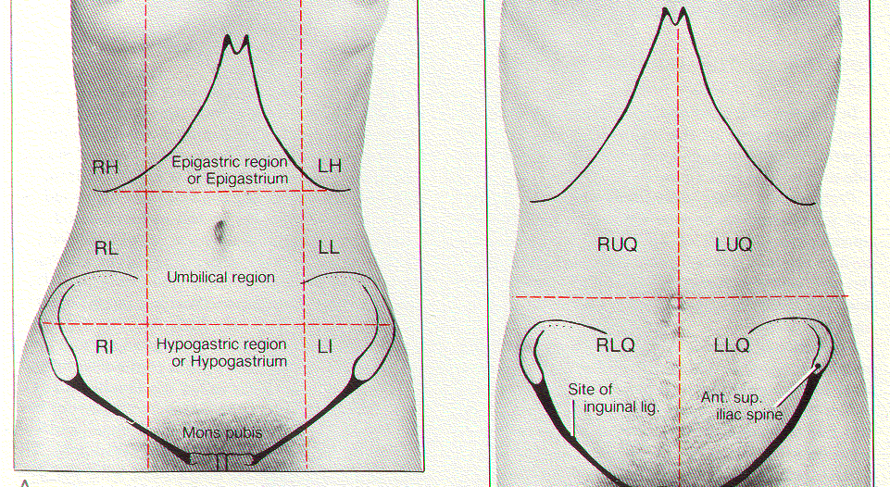

RH, LH =right, left hypochondriac RUQ, LUQ = right, left upper quadrant
LL, RL = right, left lumbar RLQ, LLQ = right, left lower quadrant
RI, LI = right, left inguinal or iliac

A superficial view:

The superficial muscles of the anterior abdominal wall include: serratus anterior (more laterally located), external oblique m., internal oblique m., transversus abdominus m., and rectus abdominus m. The superficial to deep relationship of these muscles and the fascial compartments are important to understand.

From: Clinically Oriented Anatomy, KL Moore, 2nd edition (1985)

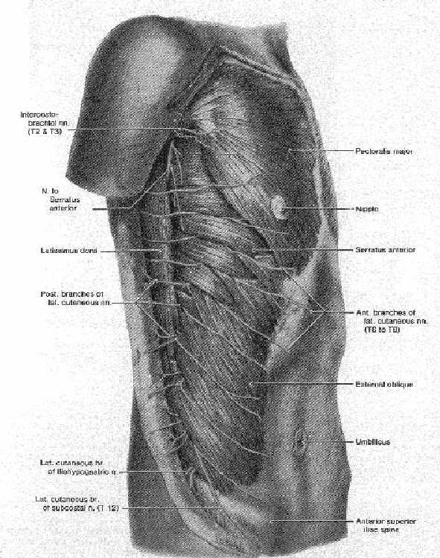

This is a lateral view of a superficial dissection of the abdomen. You may come in contact with the serratus anterior muscles during this dissection (and even the Latissimus Dorsi m.), but these are not on the anterior wall proper. The superior fibers of the external oblique interdigitate with serratus anterior while the more inferior fibers interdigitate with the latissimus dorsi. Also note the anterior branches of lateral cutaneous nerves as they pierce these muscles.
Muscles of the anterior abdominal wall:

Four muscles (the external oblique, the internal oblique, the transversus abdominus, the rectus abdominus) form the anterolateral abdominal wall. The combination of muscles and their aponeuroses provide protection for the abdominal viscera. The external oblique is oriented from superolateral to inferomedial and meets at the midline to join at the linea alba, a tendinous raphe that stretches from the xiphoid process to the pubic tubercle. The external oblique is aponeurotic as it advances towards the midline. The internal oblique lies deep to the external oblique, is oriented at right angles to the fibers of the external oblique and end in an aponeurosis that joins the linea alba. The transversus abdominus m. lies deep to the internal oblique. The fibers of this muscle run horizontally towards the midline and end in an aponeurosis that ends at the linea alba.

The Rectus Sheath:

The Rectus Sheath is the fibrous compartment of the rectus abdominis muscle. It is formed by the fusion and separation of the aponeuroses of the abdominal muscles described above.

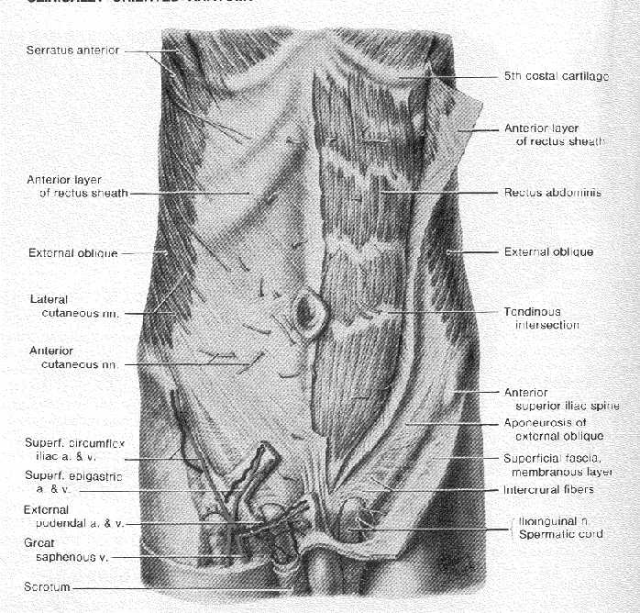
From: Clinically Oriented Anatomy, KL Moore, 2nd edition (1985)

The aponeuroses of the abdominal muscles fuse together in a very particular pattern to form the rectus sheath. The rectus sheath is an aponeurotic compartment that contains the rectus abdominus muscle. This pattern varies according to the position on the abdomen. Close to the xyphoid process (d in the following figure) the rectus sheath consists only of fibers contributed by the external oblique. At level c, the external oblique and internal oblique contribute fibers to the superficial layer of the rectus sheath, while the deep layer of the rectus sheath receives fibers from the internal oblique but mostly from the transversus abdominus. Just above the umbilicus (b in figure below), the superficial and deep layers of the rectus sheath receives fibers from the aponeurotic sections of the same muscles. At level a, above the mons pubis, the aponeurotic sections of the three flat abdominal muscles contribute to the superficial layer of the rectus sheath. Only the transversalis fascia lies deep to the rectus sheath. Immediately deep to the transversalis fascia is the parietal peritoneum.

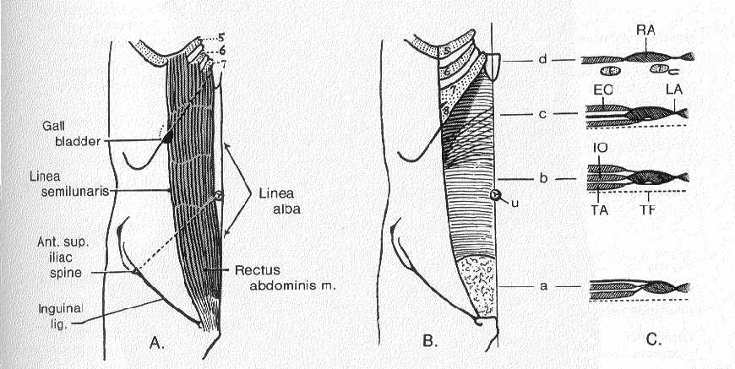
From: Clinically Oriented Anatomy, KL Moore, 2nd edition (1985)

Abbreviations: RA=rectus abdominus, LA=linea alba, EO=external oblique, IO=internal oblique, TA=transversus abdominus, u=umbilicus, TF=transversalis fascia

Inguinal ligament:

You already know that as muscle fibers of the external oblique advance towards the midline, they become aponeurotic. Consequently, below the level c in the above figure, only aponeurotic fibers from the external oblique contribute to the rectus sheath. The more inferior aponeurotic fibers of the external oblique roll under thereby forming the inguinal ligament that attaches superiorly at the anterior superior iliac spine and inferiorly at the pubic tubercle. The superficial inguinal ring is an opening at the inferior end of the inguinal ligament near the pubic tubercle. The ring represents a weakness in the anterior abdominal wall in the adult. In the developing fetus, it is the site of exit of the descending testis from the abdomen and entrance into the scrotum.

Superficial dissection of the inguinal region.
From: Clinically Oriented Anatomy, KL Moore, 2nd edition (1985)
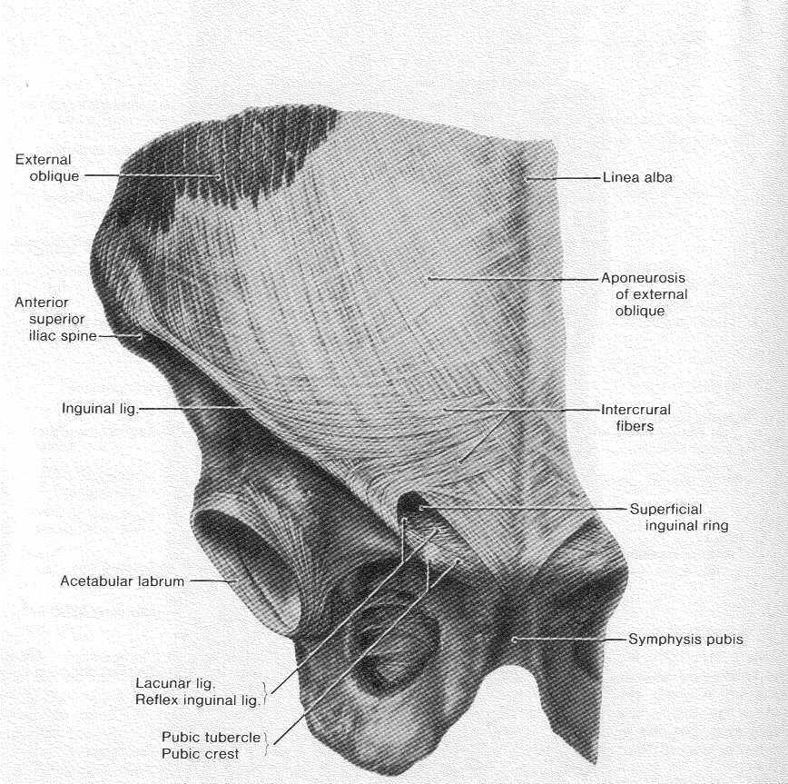

The inguinal canal:

The inguinal canal is that structure through which the testis (in the male) and the round ligament (in the female) descend during development. The testes develop within the lumbar region of the abdominal cavity between the transversalis fascia and the peritoneum. The testes migrate, or descend through the inguinal canal to enter the scrotum just before birth. The testis leaves the abdomen by way of the deep inguinal ring, an opening in the deepest layer (the transversalis fascia). The future placement of the inguinal canal is marked in development by a structure called the gubernaculum which is attached to the testis and passes from the testis into the inner wall of the scrotum by way of the anterior abdominal wall. A pocket or bubble of peritoneum called the processus vaginalis follows the gubernaculum protruding through the anterior abdominal wall to form the inguinal canal. (You can think of this like the balloon in an angioplasty procedure forming a lumen in an area that previously was closed.) The processus vaginalis pulls extensions of the layers of the abdominal wall that are already in place along with it as it descends into the testis. In males, these extensions of the various layers of the abdominal wall become the layered coverings of the spermatic cord. In both sexes, the opening produced by the processus vaginalis parting fibers of the external oblique aponeurosis is called the superficial inguinal ring. The stalk of the processus vaginalis usually becomes obliterated. That part left surrounding the testis is called the tunica vaginalis.

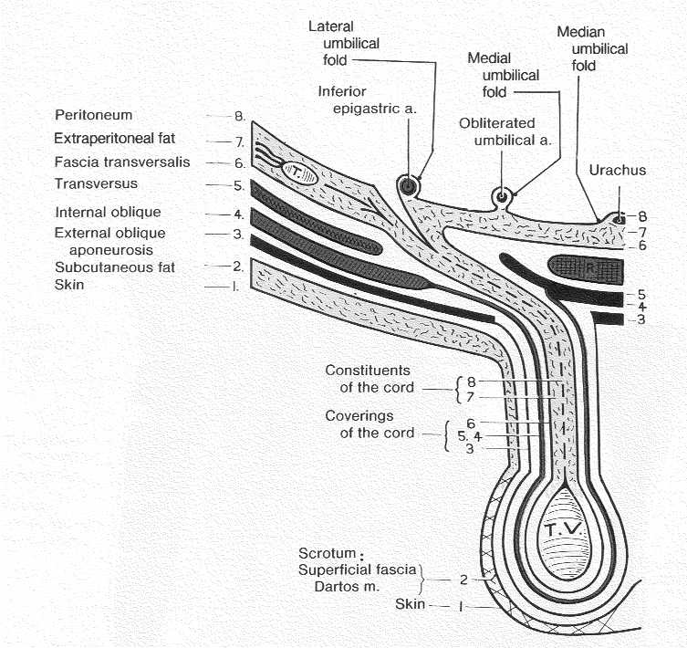

This figure from Moore (1985) provides information regarding the origin of the tissue layers of the spermatic cord from their original location in the abdomen. As the testes descend they take with them the layers of the anterior abdominal wall that get re-named when they are part of the spermatic cord.

From: Clinically Oriented Anatomy, KL Moore, 2nd edition (1985)

In the female, the ovaries migrate from where they are formed to a location within the pelvis, but they do not descend into the labium majus (the female homologue of the scrotum) via the inguinal canal. The processus vaginalis normally obliterates completely and the gubernaculum becomes attached to the uterus. The gubernaculum is divided into the ligament of the ovary and the round ligament of the uterus. The round ligament of the uterus passes through the inguinal canal in the female.

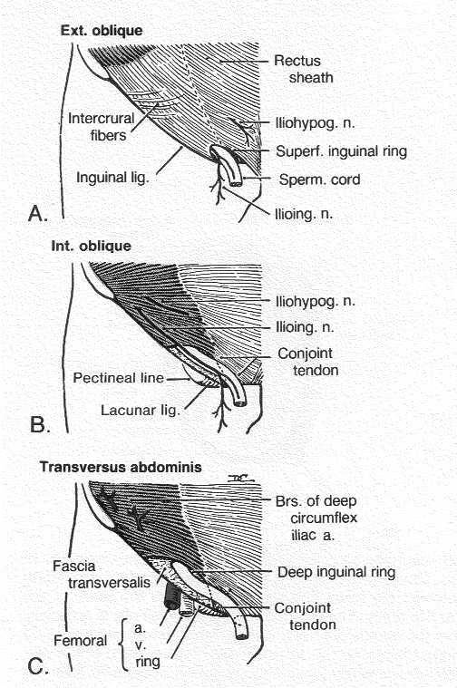
This figure taken from Moore (1985) informs you of the layers of the muscles of the abdominal wall and how they relate to the inguinal canal and its contents. This figure also shows the deep inguinal ring, which is the deep structure through which the spermatic cord (or round ligament of the uterus) leaves the abdominal cavity to enter the inguinal canal. The deep inguinal ring is deep, superior and lateral to the superficial inguinal ring. The spermatic cord contains the genetic branch of the genitofemoral nerve, lymph the ilioinguinal nerve, ductus deferens, testicular artery, cremasteric artery, artery of the ductus deferens, and the pampiniform plexus of veins.
From: Clinically Oriented Anatomy, KL Moore, 2nd edition (1985)

Hernias:

Hernia are ruptures or breakage of structures such that contents pass through the rupture, or “a protrusion of a structure, viscus, or organ from the cavity in which it belongs” (Moore, 1985). Most hernias occur in the umbilical or inguinal regions. Umbilical hernias are very common and are usually congenital. They results form incomplete

closure of the anterior abdominal wall after the umbilical cord is ligated at birth. Hernias may also occur through defects in the linea alba. The inguinal region is the most common site of hernias and hernias in this area are referred to as inguinal hernias. Females can have inguinal hernias but they are far more common in males. There are two types of inguinal hernias: direct and indirect. In both instances, an inguinal hernia results from a weakness in the anterior abdominal wall and results in the rupture of abdominal viscera through the abdominal wall.

A direct inguinal hernia protrudes directly through the posterior wall of the inguinal canal, and leaves the abdominal cavity medial to the deep ring and medial to the inferior epigastric vessels. So when entering the inguinal canal, a direct inguinal hernia does not use the deep inguinal ring. In a direct inguinal hernia, the hernial sac does not pass through the deep inguinal ring but passes through or around the conjoint tendon and directly to the superficial inguinal ring. Because of the location of the inferior epigastric vessels, just medial to the deep inguinal ring, a direct inguinal hernia leaves the abdominal cavity medial to the inferior epigastric vessels.

An indirect inguinal hernia passes through the anterior abdominal wall by entering the deep inguinal ring, passing through the inguinal canal, and emerging through the superficial inguinal ring. Therefore, an indirect inguinal hernia follows the course taken by the testis and ductus deferens when descending into the scrotum during development. Since the indirect inguinal hernia uses the deep inguinal ring as its point of exit from the abdomen, an indirect inguinal hernia leaves the abdominal cavity lateral to the inferior epigastric vessels.

