PELVIS AND PERINEUM

Study Objectives

This lecture serves as an introduction to the pelvis and perineum. Orientation, osteology, major muscles, fascial layers and certain nerves are introduced here. Circulation is not considered in this lecture. From this lecture, you should know the skeletal components of the bony pelvis, pelvic musculature including the lateral rotators of the thigh, the major course, named branches and targets of the pudendal nerve, the structure and function of the pelvic diaphragm, and the structure of the UG diaphragm.

New Terms

innominate pubis ischium
ilium sacrospinous ligament sacrotuberous ligament
acetabulum ischial spine ischial tuberosity
pelvic diaphragm pubic symphysis sacrum
coccyx rotator piriformis m.
pudendal nerve obturator internus m. obturator externus m.
greater sciatic notch greater sciatic foramen urogenital (UG) diaphragm
lesser sciatic notch lesser sciatic foramen pectin pubis
obturator canal obturator nerve gluteal region
ala

Orientation of Pelvis

The skeletal pelvis, pelvis meaning basin, is often thought of as bowl- shaped. This bowl is facing anteriorly so that most of the brim can be seen from the anterior view. The lateral view is identical from either the right or left side, as the two paired bones, the innominates, that make up the pelvis are identical. The sacrum makes up the most posterior portion of the bony pelvis. It can be seen in full from the posterior view along with the ischial tuberosities of the innominates.

In standard anatomical position, the bowl of the bony pelvis is facing anteriorly. Palpable bony landmarks (on the cadaver but more easily palpable on yourself or a willing study partner) are the anterior superior iliac spines and the crest of the fused pubic bones. When standing in anatomical position, a vertical plane can be defined that joins the anterior superior iliac spine of the innominates and the pubic tubercle of the pectin pubis. It is this standard posture which accounts for the anterior orientation of the bowl.

Osteology
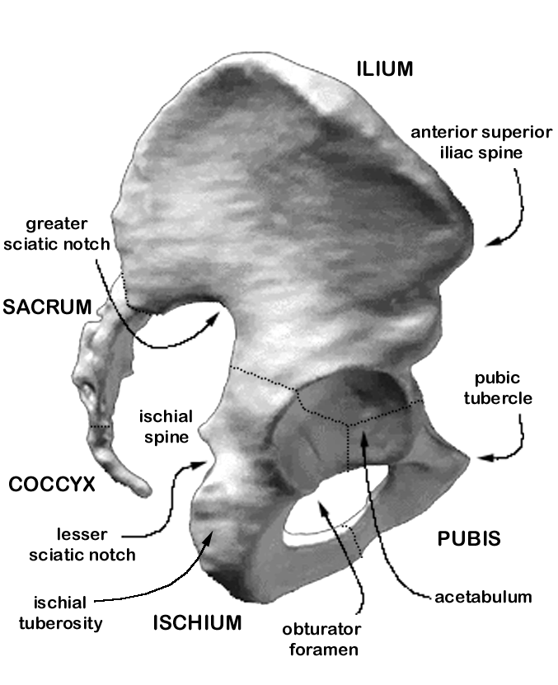
← posterior LATERAL VIEW anterior→

The innominate (or hip) bone has three parts, each having their own ossification center(s): ilium, ischium, pubis. The three bones are connected by cartilage in the immature individual but ossify to form a single bone in the adult. All three bones contribute to the acetabulum, the large bowl-shaped socket that articulates with the head of the femur at the hip joint.

The ilium forms the upper portion of the acetabulum, and is composed primarily of the ala (wing) which have a posterior or gluteal surface and an anterior surface called the iliac fossa. The gluteal surface is marked by lines that are the sites of attachment of the large, gluteal muscles. The iliac fossa provides attachment for the iliacus muscles. The gluteal surface and the iliac fossa are joined along the superior border by the iliac crest which contains many bony landmarks worth noting: anterior superior iliac spine, anterior inferior iliac spine, iliac tuberosity, posterior superior iliac spine, posterior inferior iliac spine. The inferior border of the ilium, inferior to the inferior posterior iliac spine makes up a portion of the greater sciatic notch, the rest of which is formed by the ischium. The ischial spine denotes the inferolateral extension of the greater sciatic notch and separates it from the lesser sciatic notch.

The ischium forms the inferoposterior part of the acetabulum and consists of a body and a ramus. The ramus ascends anteromedially to join the descending ramus of the pubis where it is referred to as the ischiopubic ramus. The ischial tuberosity makes up most of the posterior surface of the ischium, is the site of attachment of many hip muscles and is the structure of primary support during sitting. The ischial spine is located just superior to the ischial tuberosity, faces posteromedially, and denotes the superior border of the lesser sciatic notch.

The pubis has two rami: a superior ramus which passes from the midline laterally towards the acetabulum and an inferior ramus that passes inferolaterally to join the ischium. The left and right pubic bones join at the midline and form the fibro-cartilaginous pubic symphysis. Fusion of the ischium and pubis at the acetabulum and the junction of these two bones along the ischiopubic ramus form a large foramen, the obturator foramen, which faces anterolaterally.

The sacrum and coccyx are series of single vertebrae that fuse to form bony elements. The sacrum is formed from five independent sacral vertebrae. The superior surface of the first sacral vertebrae is called the promontory and articulates with the fifth lumbar vertebrae. The fifth sacral vertebrae articulates with the first coccygeal vertebrae, of which there are three to five. The sacrum and coccyx fuse to one another after age 40.

Joints

Articulation of the left and right innominates at the pubic symphysis and to the sacrum at the sacro-iliac joint forms a bony ring when viewed anterosuperiorly. Stability and limited flexibility are features of these joints.
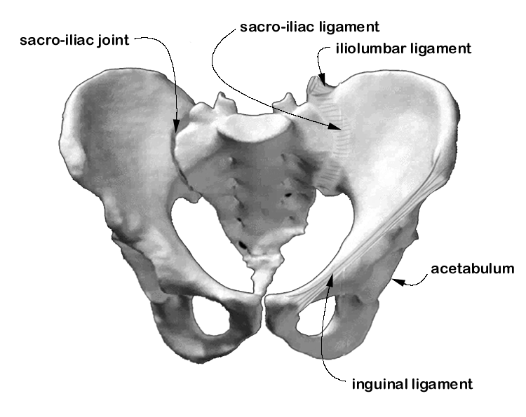
ANTERIOR VIEW

The pubic bones meet at the midline to form a fibrocartilaginous joint called the pubic symphysis. It is thought that some separation at this joint occurs during the later stages of gestation. The sacro-iliac joint is a synovial joint between the sacral and iliac auricular surfaces. Many ligaments cross the articulation and contribute to the stability of this joint.

The acetabulum holds the femur and this articulation is referred to as the hip joint. The skeletal pelvis supports and protects the abdominal and perineal viscera, but it is also a major component of the lower limbs. The skeletal pelvis is the major mechanism in transmitting upper body weight to the lower limbs. Locomotor and support mechanisms of the pelvis are considered in the lectures on the lower limb.

Ligaments
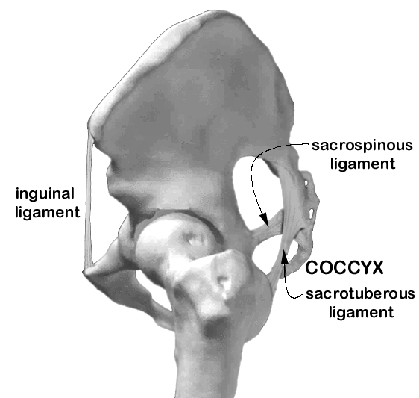

←anterior LATERAL VIEW posterior→

Ligaments of the pelvis are extremely important anatomically as they provide support and reinforcement to the skeleton and to soft tissue structures. Certain ligaments serve as critical landmarks for gaining anatomical knowledge and orientation of structures in relation to one another.

The paired inguinal ligaments pass from anterior superior iliac spine to ipsilateral pubic tubercle. The ligament is actually the rolled, inferior border of the aponeurosis of the internal oblique muscle. This ligament forms the floor of the inguinal canal.

The paired sacro-iliac ligaments and iliolumbar ligaments, named for their attachment sites, help to stabilize the sacro-iliac joint. There are both ventral and posterior sacro-iliac ligaments.

The sacrotuberous and sacrospinous ligaments cross the sacral inlet from the lateral surface of the sacrum to the more laterally placed ischial tuberosity and ischial spine, respectively. These ligaments are extremely strong and sometimes feel ossified and therefore have real consequences for limitations on measures of the pelvic cavity. On each side, the sacrotuberous and sacrospinous ligaments cross in a modified "X". When viewed posteriorly, it is evident that the sacrotuberous ligament is the more exteriorly placed of the two ligaments, as the ischial tuberosity projects more posteriorly than the ischial spine with the pelvis in anatomical position. The sacrotuberous ligament crosses a longer interval making it relatively longer than the sacrospinous ligament.

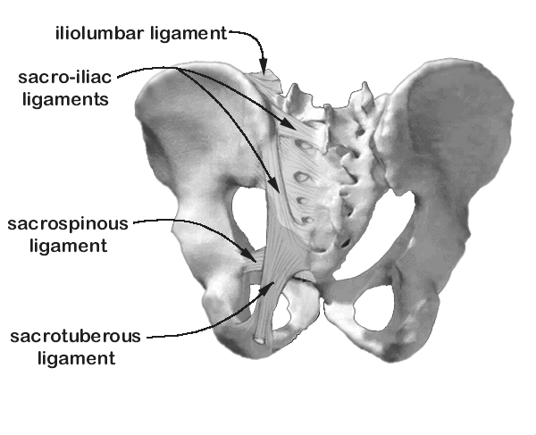
POSTERIOR VIEW

The relationship of the sacrotuberous ligament, sacrospinous ligament, greater sciatic notch, lesser sciatic notch, greater sciatic foramen and lesser sciatic foramen are key to understanding the anatomy of the bony pelvis as well as soft tissue relationships of the pelvis and perineum. Viewing these structures in three dimensions from several views will help clarify their relationships. Note that the relationships are better viewed on a half pelvis (mid sagittal view) as the cavity of the lesser pelvis is quite small and mostly obstructed by the acetabulum and ischium when viewed laterally. The placement of the sacrospinous ligament closes off the osseous greater sciatic notch creating the greater sciatic foramen. The sacrotuberous ligament forms the inferomedial border of the greater sciatic foramen. Much in the same way, the placement of the more robust sacrotuberous ligament forms the lesser sciatic foramen from the osseous lesser sciatic notch. The sacrospinous ligament helps to form the superior border, or roof, of the lesser sciatic foramen.

Pelvic musculature

Muscles of the pelvis include those that work on the lower limb (collectively referred to as lateral rotators of the thigh) and the pelvic diaphragm which is made up of levator ani muscle and coccygeus muscle. All somatic innervation is provided by branches of the lumbosacral plexus.

Lateral rotators of the thigh

The piriformis muscle is a strong lateral rotator of the thigh and is also a muscle of particular importance in gaining orientation within the dissection of the pelvis and perineum. It is a large muscle that can be as thick as a fat cigar from front to back and covers the lateral portions of sacral vertebrae 2, 3, and 4 just lateral to the pelvic foramina of these vertebrae. Originating on the pelvic

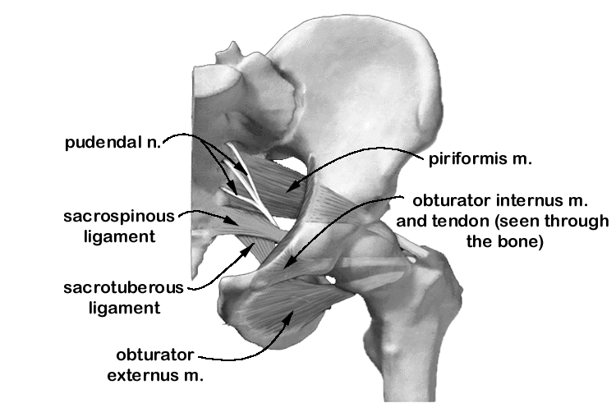
ANTERIOR VIEW

surface of the sacrum, the piriformis muscle leaves the pelvis via the greater sciatic foramen (which it nearly fills) and attaches to the medial side of the superiormost point of the greater trochanter of the femur. When viewed laterally, the direct alignment of this muscle can be appreciated as can its potential strength as a lateral rotator of the thigh. The piriformis is innervated by sacral nerves 1 and 2 through small branches of the sacral plexus.

The obturator internus muscle originates within the pelvis on the obturator membrane (a membrane that closes all but the superior border of the obturator foramen) and on portions of the ischium and ilium lateral to the obturator foramen. Though broad in origin, the muscle merges to a narrow tendon that passes through the lesser sciatic foramen and rides over the ischial body (over a bursa) just superior to the ischial tuberosity to attach on the medial aspect of the greater trochanter of the femur. The slim tendon of the

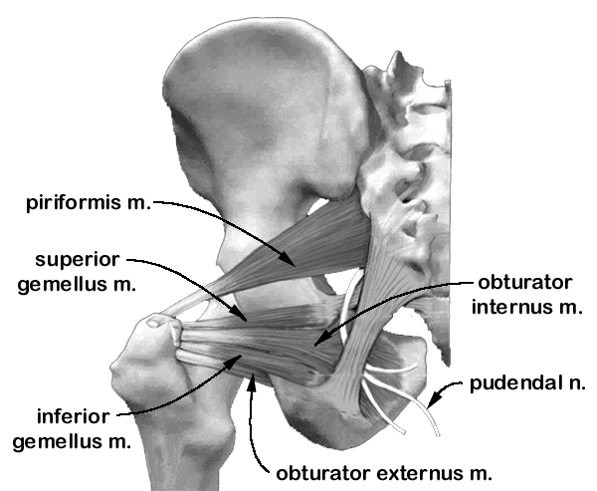

POSTERIOR VIEW

obturator internus muscle is often hidden from view by the tendons of the superior gemellus and the inferior gemellus muscles. These muscles flank the tendon of the obturator internus muscle as they pass from their origin on the posterior aspect of the ischial body (superior gemellus from the ischial spine; inferior gemellus from the ischial tuberosity) and insert into the tendon of the obturator internus muscle. The tendons are shown independently and exagerated in the figure above to clarify their relative positions. Both gemelli muscles are lateral rotators. The course of the muscle as it originates from the obturator membrane is primarily lateral, but as the muscle courses over the ischium, it turns sharply laterally, making nearly a 90º turn. The orientation and course of the obturator internus muscle is not intuitive and cannot be appreicated on the figure drawn here. Exercises with the 3D models presented in the web lecture, a bony pelvis, or a dissected cadaver are strongly encouraged for study. The obturator internus is innervated by sacral nerves 1 and 2 through small branches of the sacral plexus. We will learn later that a major part of the pelvic diaphragm attaches to the fascia of the obturator internus.

The obturator externus muscle takes its origin from the external or anterior surface of the obturator membrane and from the bone that surrounds the obturator foramen. Like the obturator internus, the obturator externus converges to a slim tendon over the ischium and passes superiorly behind the femoral neck to insert on the trochanteric fossa of the femur.

ANTERIOR VIEW

Three-dimensional models are needed to appreciate the angle used by this muscle to pass from the anterior surface of the obturator membrane to the posterior aspect of the femur. The obturator externus muscle is primarily a lateral rotator of the thigh and is supplied by the obturator nerve as it leaves the pelvis.

Note that both the piriformis and the obturator internus muscles take their origin within the pelvis but exit to find their site of attachment outside of the pelvis. The route they take is important to understanding their biomechanical advantage and their relationship to other structures. Note too the sacrospinous and sacrotuberous ligaments joining the sacrum to landmarks of the ischium. Knowledge of the relationships of these lay a solid foundation for the more complex anatomy of the perineum.

The pelvic diaphragm

The second group of muscles arising from within the pelvis includes the levator ani and coccygeus muscles which together form the pelvic diaphragm. The pelvic diaphragm is a thin, muscular sheet that separates the pelvis from the perineum. The term sheet is misleading however, as the diaphragm is not a flat structure, and is conveniently thought of as funnel shaped. This funnel fits into the pelvic cavity.
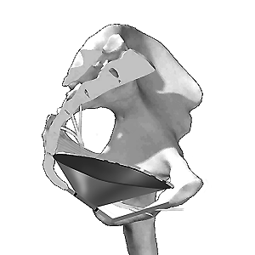
←posterior MID SAGITTAL VIEW anterior→

These structures originate along, and are attached to a reinforced portion of the fascia of the obturator internus muscle which is called the tendinous arch. The fascia covering the obturator internus muscle above this line is composed of the obturator fascia, the superior and inferior pelvic diaphragmatic fascia, and the degenerated aponeurosis of levator ani. Fusion of these fascias forms a thickening called the tendinous arch of the levator ani. This arch extends into a broad band stretching from the pubic symphysis to the ischial spine. This extension is the tendinous arch of the pelvic fascia. These arches are visualized as a single, broad thickening of fascia. Upon palpation the tendinous arch feels much like a strong rubber band. The approximate location of the tendinous arches are shown as a dotted line on the figure below.

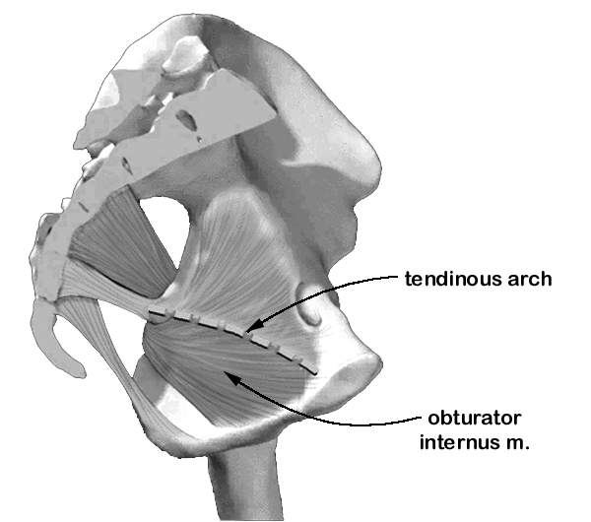

←posterior MID SAGITTAL VIEW anterior→

The pelvic diaphragm is made up of two muscles: levator ani muscle and coccygeus muscle. Although the naming of the various muscles within levator ani vary, for the purposes of this introductory lecture, we consider the following three muscles to be named parts of levator ani: puborectalis, pubococcygeus and iliococcygeus.

Several structures pass through the pelvic diaphragm including the rectum, the urethra, and in the female, the vagina. The most posterior of these pelvic effluents is the rectum. The rectum is surrounded by bands of muscle called the puborectalis muscle. The muscles originate on either of the posterior aspect of the body of the pubis and pass posteriorly to join muscle fibers of the contralateral side behind the rectum. The puborectalis joins the external anal sphincter however and forms a sling around the rectum producing a flexure at the anal rectal junction.

posterior
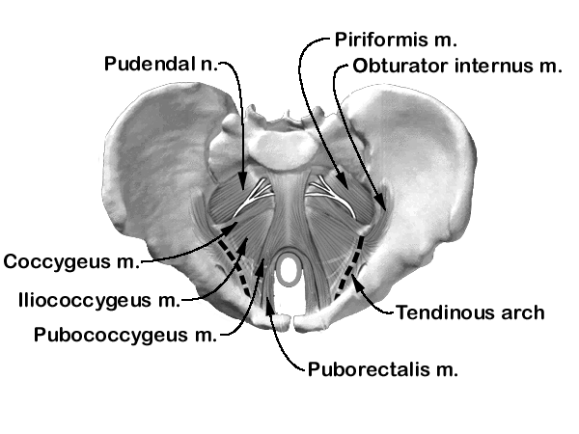
anterior

SUPERIOR VIEW

The puborectalis muscle is barely distinct from the pubococcygeus muscle at the posterior side of the pubic bodies where both muscles take their origin. However, the pubococcygeus passes posteriorly in a plane superior to that traversed by the pubrectalis and inserts on the anterior surface of the coccyx. Certain portions of the pubococcygeus muscle are assigned names that specify their insertion into other structures as the whole muscle passes posteriorly towards the coccyx. These include the fibers that insert into the sphincter urethrae (and in the male into the prostate), into the vagina in females, and into the perineal body (see below) and the rectum in both males and females.

The iliococcygeus muscle is that part of levator ani that takes its origin from the band of tissue on the internal fascia of the obturator internus muscle known as the arcus tendinous and from the ischial spine. This muscle extends posteromedially to insert on the final segments of the coccyx. The muscles of levator ani are innervated by the pudendal nerve and by independent branches of sacral nerves 2 and 3.

The coccygeus muscle, which together with the levator ani makes up the pelvic diaphragm, lies on the anterior surface of the sacrospinous ligament. Consequently, during the gluteal dissection, only the sacrospinous ligament can be visualized as it overlies the coccygeus muscle. An abdominal approach to the same region will enable visualization of the coccygeus muscle overlying the sacrospinous ligament. Its attachments are the ischial spine laterally, and the coccyx posteriorly. It is innervated by sacral nerves 3 and 4.

The posterior view and the mid-sagittal view (see preceding figures) provide alternate perspectives on the course of the pudendal nerve. Roots of the nerve leave the pelvic foramen of sacral vertebrae 2, 3 and 4 on the pelvic surface and join to form the nerve proper. Once formed, the nerve leaves the pelvis via the greater sciatic foramen and enters the perineum using the lesser sciatic foramen and thereby finds its way to its target organs without penetrating the pelvic diaphragm.

Remember that the pelvic diaphragm is the superior limit of the perineum. Shown here is an inferior, or worm's eye, view of the pelvic diaphragm without the perineum superimposed.
anterior
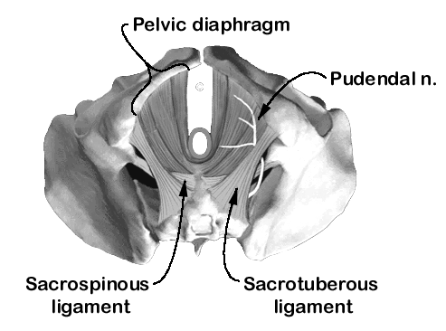
posterior

INFERIOR VIEW

The Perineum

The perineum is one of the most difficult parts of the body to understand, learn and to dissect. There are several reasons for this. First, the muscles are extremely thin and friable, sometimes appearing to be only wisps of muscle fiber in older cadavers. In the dissection laboratory, students often plow through the structures looking for sizeable muscles as they appear only in textbooks. Second, access to the perineum is difficult in dissection. Approached through the pelvic diaphragm, limited space prevents access to all perineal structures. Approached from the external or inferior surface of the perineum, the thighs, especially in obese cadavers can prevent easy access to the structures. Our advice is to learn the structures from this lecture and from dissection photographs, realizing that you are seeing exaggerated views or specimens chosen specifically for demonstration of the perineum. Be prepared for small and fragile muscles when dissecting in the laboratory.

The perineum is that region inferior to the pelvic diaphragm and extends to the skin of the buttocks, thighs and external genitalia. The skeletal limits of the perineum are the same skeletal boundaries as those of the pelvic outlet. The anterior limit is the pubic arch. The boundary outline follows the pubic and ischial rami to the ischial tuberosity and follows the sacrotuberous ligament to the tip of the coccyx. The perineum is often described as diamond shaped, made up of two triangles, the urogenital triangle anteriorly and the anal triangle posteriorly. Note that these two triangles do not lay on a single plane: an angle exists between the urogenital triangle, anteriorly, and the anal triangle posteriorly. This is more easily appreciated when viewed laterally.

Contents of the urogenital triangle are commonly referred to as the urogenital (or UG) diaphragm, but the 38th edition of Gray's Anatomy (Williams et al., 1995) states that the muscles of the urogenital region "do not form a diaphragmatic sheet, but extend through the visceral outlet into the lower reaches of the pelvic cavity; thus there is no urogenital diaphragm as such" (Williams et al., 1995: 832). We therefore refer to this region as the urogenital triangle but be aware that it is referred to as the urogenital diaphragm in most anatomy text books.

anterior
posterior

INFERIOR VIEW

Anal triangle

The anal triangle contains the wedge-shaped ischiorectal fossa on either side of the anus which hold two extensive fat pads. These fat pads are liquid at body temperature allowing easy distention of the rectum and anus during defecation. The pudendal nerves and internal pudendal vessels course through the ischiorectal fossa within a fascial compartment called the pudendal canal. The pudendal canal is fused to the obturator fascia and passes its contents forwards along the inferior pubic rami. The inferior rectal nerve (a branch of the pudendal) and the inferior rectal vessels are also found in the ischiorectal fossa.

The external anal sphincter surrounds the lowest part of the anus and is bound to the overlying skin. The internal anal sphincter is not truly part of the anal triangle but is mentioned here to complete the anatomy of the anal sphincter. Like all sphincters, the anal sphincter is closed at relaxation. The tone of these sphincters keeps the lateral walls of the anal canal closed except when consciously relaxed during defecation or during the "pushing" involved in childbirth.

anterior

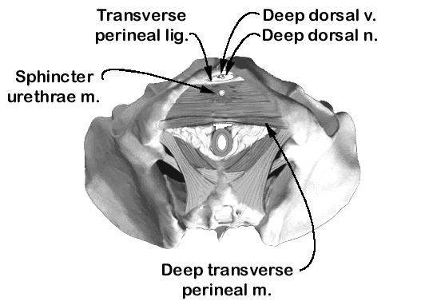
posterior

INFERIOR VIEW

The urogenital triangle

The urogenital (UG) triangle consists of muscles and fascial layers that are difficult to dissect and therefore often unappreciated (or seen!) in the cadaver. This introduction will help to prepare you for dissection. We present a general summary of this region and indicate male/female differences. Be sure to view dissections of both male and female cadavers in the laboratory.

Deep muscles of the UG triangle. There is both a superficial and deep group of muscles in the urogenital triangle. We focus here on the deep group. Many presentations of the perineum take an approach that begins with the superficial structures, working through them to expose the deeper structures. Since we have presented the pelvic diaphragm first, we will continue our presentation with the deep group and then consider the superficial group. The deep space of the urogenital triangle contains a thin sheet of muscle that stretches between the ischiopubic rami. The body of this muscle, with some regions being named, is sandwiched between two fascial layers, one deep or superior (closer to the pelvic diaphragm) and one more superficial or inferior (closer to the superficial perineal muscles).

The named muscles of the deep perineal space include the deep transverse perineal muscle (transversus perinei profundus) and the sphincter urethrae muscle. The sphincter urethrae muscle surrounds the membraneous urethrae at the level of the deep perineal space and the neck of the bladder. In the male, central fibers continue into the prostate. The deep transverse perineal muscles take their origin from the ischial rami and cross laterally just anterior to the anus join the muscle of the other side. The perineal body, a mass of decussating fibers from several muscles in the deep and superficial compartments and a site of fusion of the inferior and superior fascial layers, is located in the midline between the anus and urogenital structures just superficial to the site of the intersection of fibers of the right and left transversus perinei profundus muscles. Muscle fibers (and their fascias) that interlace to form the pyramidal shaped perineal body include all of the muscles of the deep and superficial groups as well as the smooth muscle of the internal anal sphincter.

The transverse perineal ligament is a reinforced strap of fused fascial layers that border an opening in the urogenital triangle anterior to the urethrae and transmit the deep dorsal vein of the penis/clitoris.

The muscles of the deep perineal space are covered inferiorly by the inferior fascia of the urogenital diaphragm, sometimes called the perineal membrane. As stated above, the deep perineal space includes the deep perineal muscles that are sandwiched between two named fascial layers: the superior fascia of the urogenital diaphragm and the inferior fascia of the urogenital diaphragm.

Superficial muscles of the UG triangle. The muscles of the superficial perineal space include the superficial transverse perineal muscles, the paired bulbospongiosus muscles, and the paired ischiocavernosus muscles. The perineal body receives fibers from muscles in both the deep and superficial groups and was described previously. Transversus perinei superficialis is a small strip of muscle that passes from each ischial tuberosity towards the midline. There it inserts into the perineal body and intermingles with fibers from the contralateral muscle. Bulbospongiosus is a midline muscle that consists of two parts joined by a median raphe.

In the male the fibers of the bulbospongiosus surround the bulb of the penis and the corpus spongiosus of the penis. The ischiocavernosus muscle cover the crus of the penis. On each side, the muscle originates from the ischial tuberosity and ramus.

anterior

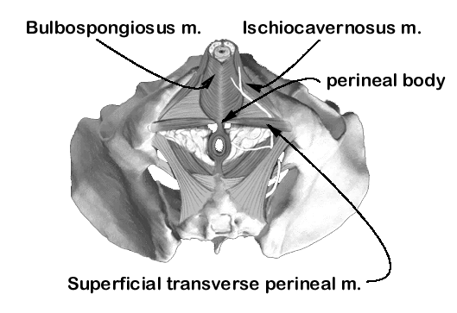
posterior

MALE: INFERIOR VIEW

In the female the muscles of the superficial perineal space are named the same as in the male but their structure is obviously quite different. In the female, bulbospongiosus covers the superficial parts of the vestibular bulbs and greater vestibular glands and passes forward on either side of the vagina to attach to the body of the clitoris. Ischiocavernosus originates from the ischial tuberosity and ramus but covers the crus of the clitoris which are much smaller than the penile crus.

anterior

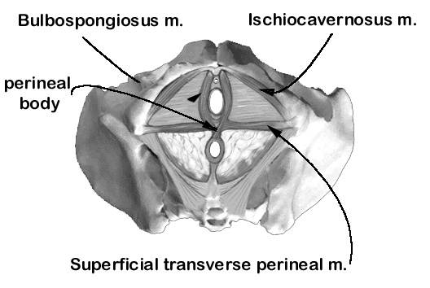
posterior

FEMALE: INFERIOR VIEW

